MULTIPLE FRUIT QUALITY ASSESSMENT SYSTEM
A Project Report submitted

in partial fulfilment for the Degree of

Bachelor in Engineering

in

Electronics and Telecommunication Engineering

by
Shital Bhadre
Ibtesam Pathan
Sahil Kangane
Pursued in
Department of Electronics and Telecommunication Engineering
Program: E & TC

Progressive Education Society’s
Modern College of Engineering
Shivajinagar, Pune-05


SAVITRIBAI PHULE PUNE UNIVERSITY

Academic Year: 2024-25

CERTIFICATE

This is to certify that,’MULTIPLE FRUIT QUALITY ASSESSMENT SYSTEM’

Submitted By

Shital Bhadre Exam No. B400310257

Ibtesam Pathan Exam No. B400310346

Sahil Kangane Exam No. B190310305

to the PES’s Modern College of Engineering, Shivajinagar, Pune, in partial fulfilment for the award of the degree of BE in (E & TC, Program: E & TC) is Project Phase II work carried out by them under my supervision.

Prof.Ms.M.M.Deshpande Prof. Dr. Mrs. R. S. Kamathe

Project Guide H.O.D., (E&TC)

DECLARATION
We declare that this project report titled MULTIPLE FRUIT QUALITY ASSESSMENT SYSTEM.submitted in partial fulfilment of the degree of BE ( E & TC) is a record of original work carried out by us under the guidance of Prof.Ms. M.M. Deshpande,and has not formed the basis for the award of any other degree or diploma, in this or any other Institution or University. We declare that this written submission represents the ideas in our own words. In keeping with the ethical practice in reporting scientific information, due acknowledgements have been made wherever the findings of others have been cited. We also declare that we have adhered to all principles of academic honesty and integrity and have not misrepresented or fabricated or falsified any idea/data/fact/source in the submission.
Shital Bhadre
Ibtesam Pathan
Sahil Kangane

ACKNOWLEDGEMENT

Firstly, we would like to express our gratitude towards our Project Guide Ms. Meghana Deshpande.Who was a continual source of inspiration. She pushed us to think imaginatively and urged us to do this project without hesitation. Their insightful feedback and constructive criticism helped me to refine my ideas and produce a better final product. We are also grateful to our Principal Dr. Mrs. K.R. Joshi and Our HOD Dr. Mrs. R. S. Kamthe for providing us with the opportunity to work on this project and for their constant support and encouragement. We extend our sincere thanks to the project coordinators Dr. Mrs. Kanitkar and Mr Ramgopal Sahu for their guidance, support, and invaluable feedback throughout the project. Their expertise and experience helped me to stay on track and achieve the project goals. In addition, I extend my heartfelt thanks to the participants who generously gave their time and cooperation to make this project a success. Their valuable insights and feedback provided crucial information for the analysis and conclusions of this project. Finally, We want to express our gratitude to our family and friends for their constant support and encouragement throughout the project. Their unwavering belief in my abilities has been a great source of motivation for me.Thank you all once again for your invaluable support and contribution to this project.

Name of the Student
1. Shital Bhadre
2. Ibtesam Pathan
3. Sahil Kangne

ABSTRACT

This project presents a real-time Multiple Fruit Quality Assessment System designed to classify fruit types and evaluate their quality using deep learning and computer vision on edge devices. The system utilizes MobileNetV2 with transfer learning, trained on a custom FruitVision-based dataset comprising 3,200 labeled images of apples, bananas, mangoes, and oranges. Each image is annotated with both fruit type and quality (fresh or rotten), and is uniformly resized to 224×224 pixels for compatibility with CNN architectures.
Image acquisition was performed using a 1/4 CMOS 640x480 USB camera with a collapsible cable, selected for its cost-effectiveness, USB plug-and-play support, and suitability for low-resolution real-time applications. The system is deployed on a Raspberry Pi 4B (4GB RAM) using TensorFlow Lite, enabling low-latency inference suitable for embedded and portable solutions.
A complete processing pipeline including image capture, preprocessing, feature extraction, training, and real-time quality grading was developed to automate and replace traditional manual fruit inspection methods. The dataset follows a structured format, managed via CSV and JSON label mappings, and is split into training (70%), validation (15%), and test (15%) subsets. The model was optimized for lightweight deployment and high inference speed on constrained hardware.
This solution demonstrates the potential of edge AI in agricultural automation, offering a non-invasive, consistent, and reliable method to assess the external quality of fruits. It contributes to reducing manual labor, enhancing quality control, and supporting real-world applications in food processing, retail, and smart farming environments.
The need for a multiple fruit quality assessment system arises due to several limitations in traditional fruit grading methods. Manual inspection of fruits is time-consuming, labor-intensive, and often inconsistent due to human error and fatigue. With the growing demand for automation in agriculture and smart farming practices, there is a strong necessity for an intelligent system that can automatically evaluate fruit quality with high accuracy and speed.
TABLE OF CONTENT

DESCRIPTION PAGE NUMBER
CERTIFICATE ii
DECLARATION iii
PLAGIARISM REPORT iv
ACKNOWLEDGEMENT viii
ABSTRACT ix
LIST OF FIGURES x LIST OF TABLES
- INTRODUCTION 01
- LITERATURE SURVEY
  - Literature Survey 03
  - Market Survey 04
  - Component Survey
    - Comparison Table of Hardware Platform for 11
the Multiple Fruit Quality Assessment System.
    - Comparison Table of Camera Module for 12
    - the Multiple Fruit Quality Assessment System.

  - Observation of the Literature Survey and 13
Market Survey

  - Problem Statement. 15
    - Aim and Objectives
    - Statement of the Scope. 15

  - Methodologies 16
  - Outcome 17
  - Applications 17

- SPECIFICATION OF THE PROJECT
  - Electrical Specifications 18
  - Mechanical Specifications 19

- BLOCK DIAGRAM AND DESCRIPTION 20

- HARDWARE SYSTEM DESIGN
  - Hardware Resources. 26
  - Description of Hardware used. 26
  - Enclosure Design of the Project. 27

- SOFTWARE SYSTEM DESIGN
  - Software Resources. 28
  - Algorithms. 29
  - Flowchart. 30

- RESULTS AND PERFORMANCE EVALUATION
  - Photo of Project with enclosure 31
  - Photo of Project without enclosure. 32
  - Operating Procedure of Multiple Fruit Quality 32
Assessment System
  - Necessary Precautionary. 33
  - Results and Discussions. 34

- CONCLUSION AND FUTURE SCOPE 46

- BILL OF MATERIAL 48

- REFERENCES AND BIBLIOGRAPHY 49

- APPENDIX I List of Fruit Quality Standards 55

- APPENDIX II Datasheet of Raspberry Pi 4B 56

LIST OF FIGURES

Sr. No. | Title of the Figure | Page No.
4.1 | Block diagram of Multiple Fruit Quality Assessment System. | 23
4.2 | Dataset sample from FruitVision | 25
4.4 | MobilenetV2 Architecture | 26
5.2.1 | Hardware Design of Multiple Fruit Quality Assessment System. | 30
6.3.1 | Flow Chart of Multiple Fruit Quality Assessment System. | 33
7.1 | Photo of Multiple Fruit Quality Assessment System with enclosure. | 34
7.2 | Photo of Multiple Fruit Quality Assessment System without enclosure. | 35
7.5.1 | Accuracy curves for MobileNetV2 Fruit model across different epochs | 37
7.5.2 | Loss curves for MobileNetV2 Fruit model across different epochs | 38
7.5.3 | Accuracy curves for MobileNetV2 Quality model across different epochs | 38
7.5.4 | Loss curves for MobileNetV2 Quality models across different epochs | 39
7.5.5 | Confusion matrix obtained for the MobileNetV2 models. | 40
7.5.7 | Curves of f1 - confidence for MobilenetV2 models across distinct classes | 42
7.5.8 | Curves of Precision - confidence for MobilenetV2 models across distinct classes | 43
7.5.9 | Curves of Recall - Confidence for MobilenetV2 models across distinct classes | 44
7.5.10 | Curves of Precision - Confidence for MobilenetV2 models across distinct classes | 45
7.5.11 | Real-Time Fruit Classification and Quality Assessment Results | 47

LIST OF TABLES

Sr. No. | Title of the Table | Page No.
2.3.1 | Comparison Table of Hardware Platforms for Multiple Fruit Quality Assessment System | 13
2.3.2 | Comparison Table of Camera Modules for Multiple Fruit Quality Assessment System | 14
3.1.1 | Electrical Specification of Multiple Fruit Quality Assessment System. | 22
3.1.2 | Mechanical Specification of Multiple Fruit Quality Assessment | 22
5.1.1 | Hardware Requirements of Multiple Fruit Quality Assessment Systems. | 29
7.5.6 | Performance Parameter of MobileNetV2 models. | 41
7.5.11 | Comparison of models on accuracy | 48
9.1 | Bill of material | 52

1.INTRODUCTION

The increasing demand for high-quality, nutritious, and safe food has driven the need for intelligent and automated systems in the food supply chain. Fruits, being an essential part of a balanced diet, are highly perishable and susceptible to microbial contamination and decay. Manual inspection methods—traditionally used to assess fruit quality based on visual cues such as color, size, and shape—are time-consuming, subjective, and often inaccurate. These limitations can result in the distribution and sale of spoiled or unsafe fruits, negatively impacting both public health and business credibility.[1]
This project proposes a real-time automated fruit classification and freshness assessment system powered by deep learning (DL) . The system leverages a lightweight MobileNetV2-based convolutional neural network (CNN) to identify fruit type (apple, banana, mango, orange) and determine quality (fresh or rotten) from captured images. The model is trained on a custom dataset of 3,200 labeled images and optimized for both accuracy and computational efficiency.[2]
The novelty of this work lies in its dual focus: achieving high predictive performance while also ensuring energy efficiency, enabling deployment on resource-constrained edge devices such as the Raspberry Pi 4B. While previous studies prioritized accuracy, few have explored the trade-off between performance and hardware efficiency in fruit freshness detection—marking a key research gap that this study addresses.[3]
The system is implemented using TensorFlow Lite (TFLite) for real-time inference and integrated with a Raspberry Pi-based platform equipped with a webcam and user interface. It allows users to capture fruit images, instantly receive classification and freshness results, and store annotated images locally. The interface presents confidence scores, enhancing transparency and decision-making in fruit inspection processes.[4]
By integrating AI, IoT, and embedded computing, the proposed system delivers a cost-effective, scalable, and accurate solution for stakeholders in agriculture, retail, and logistics. It aims to reduce food waste, ensure consumer safety, and automate quality control in the fruit supply chain—aligning with modern industry goals of digitalization and sustainable practices.[5]
Deep learning, particularly convolutional neural networks (CNNs), has revolutionized image classification tasks in recent years. These models are capable of automatically learning complex visual patterns without requiring manual feature extraction, making them ideal for agricultural applications where variability in texture, lighting, and appearance is common. The combination of DL with embedded systems unlocks opportunities for building intelligent, low-cost, and portable devices tailored for real-world deployment[6].
In recent years, food safety and waste reduction have emerged as critical challenges in the global food supply chain. According to the Food and Agriculture Organization (FAO), nearly one-third of all food produced globally is lost or wasted, with fruits and vegetables accounting for a significant portion. This waste is often exacerbated by inefficient handling and delayed quality inspection, especially in post-harvest supply chains. As a result, the development of intelligent inspection systems has become a key focus area in smart agriculture and precision food monitoring.[7]
From small-scale farmers to large-scale distributors, stakeholders across the fruit supply chain often lack affordable, real-time tools for evaluating fruit quality. By providing an intuitive and accurate inspection system, this project not only supports operational efficiency but also empowers users to make informed decisions—reducing dependency on expert inspectors, minimizing food spoilage, and enhancing consumer trust in product quality.[8]
Food safety, quality control, and waste reduction have become critical challenges in the global food supply chain. Fruits, which are highly perishable, contribute significantly to food loss due to inefficient handling and delayed inspection. Traditional manual methods for assessing fruit quality are slow, subjective, and error-prone, highlighting the need for intelligent, automated solutions.[9]
Deep learning, particularly convolutional neural networks (CNNs), has shown great promise in automating assessment at the edge—bridging the gap between AI and practical deployment.This project addresses this need by proposing a lightweight, MobileNetV2-based system for real-time fruit classification and freshness detection, optimized for performance and energy efficiency in resource-constrained environments.[10]

2.LITERATURE SURVEY

2.1 Literature Survey
Barcode-less Fruits Classification Using Deep Learning (2024, IAES International Journal of Artificial Intelligence)Achieved a training accuracy of 97.4%, demonstrating strong learning. Testing accuracy was 88.6%, indicating good generalization. A dataset of 44,406 fruit images was collected and preprocessed for training with a CNN model designed for fruit recognition.:The dataset, while substantial, may not capture the full range of fruit variations, including different ripeness stages, sizes, and growing conditions.The model's 11.4% testing error rate suggests that it may misclassify certain fruit types.The model's performance is likely influenced by image quality factors like lighting, focus, etc.Poor image quality could lead to inaccurate classifications.Unaccounted real-world factors like occlusions and background clutter may not be suitable for real-time applications.Limited to specific fruit types in the dataset.[1]
A Deep Learning Approach for Fruit Recognition and Nutrition Detection (2024, Journal of Food Engineering)A CNN 15-layer model achieved 99.12% accuracy across 18 fruit types. Six different deep learning architectures were explored, including VGG16, ResNet50, and InceptionV3, using Fruit-360 and Fruits and Vegetables Image Recognition datasets.Risk of overfitting, especially with complex models.Model performance might be affected by image quality (e.g., lighting, resolution).[2]
Fruit Quality Detection Using Deep Learning for Sustainable Agriculture (2024, Journal of Agricultural Engineering)The model successfully identifies fruit quality, reducing human error and improving efficiency. A diverse dataset of fruit images, encompassing various varieties and quality levels, was used for training and testing.The system might have difficulties in identifying subtle or complex defects, especially if they are not well-represented in the training data.The model's performance is likely influenced by image quality factors like lighting, focus, etc.[3]
Fruit Recognition with DenseNet-201 and Xception Models (2023)DenseNet-201 and Xception achieved accuracies of 99.87% and 98.94% on the Fruits-360 dataset, and 99.13% and 97.73% on the Fruit Recognition dataset, respectively.Environmental conditions, such as lighting, weather, and plant growth stage, can influence image quality and model performance, potentially leading to decreased accuracy in certain situations.Training and deploying deep learning models can be computationally intensive, requiring significant hardware and software resources.[4]
Fruit Scan - Disease Identification in Fruits Using Image Processing (2024, International Journal for Research)Explores the use of image processing techniques for identifying fruit diseases, using machine learning and deep learning models trained on datasets of healthy and diseased fruits.Training and deploying deep learning models can be computationally expensive, especially for large-scale applications.Complex models like ResNet and DenseNet may require significant computational resources and longer training times.[5]
Facilitated Machine Learning for Image-Based Fruit Quality Assessment (2023, Journal of Food Engineering)A study evaluating Vision Transformers for image-based machine learning in fruit quality assessment, tailored for non-experts with limited computational resources.Lack of specific details on dataset size and variety Potential challenges in real-world scenarios (e.g., lighting conditions)Resource-intensive training and inference processes.[6]
Hybrid Deep Learning Architecture for Apple Foliar Disease Detection (2023, Computers)Introduced a deep learning model combining CNNs and vision transformers for improved apple leaf disease detection, surpassing state-of-the-art methods.Computational Cost: Deep learning models can be computationally expensive to train and deploy, especially for real-time applications.Occlusions and Overlapping: The model may have difficulty classifying fruits that are partially occluded or overlapping with other objects.[7]
Improved Multi-Scale Region of Interest Deep Learning Model for Fruit Disease Classification (2024)Designed a deep learning model to classify multiple diseases in single fruit images, improving fruit disease classification efficiency.Training and deploying deep learning models can be computationally intensive, requiring significant hardware and software resources.The model's 10% error rate suggests that it may misclassify growth stages[8]
Efficient Deep Learning Model for Tomato Disease Detection (2024, Plant Methods)A model developed for tomato plant disease detection, demonstrating high accuracy and contributing to improved disease management in tomato cultivation.The focus on melons may restrict the applicability of the findings to other types of fruits. If the generated images do not closely resemble real melons, it could negatively impact the training and performance of the YOLOv9 model.[9]
Real-Time Automatic Citrus Fruit Grading-Sorting Machine Using Adaptive Deep Learning (2023, Robotics and Computer-Integrated Manufacturing)Development of a citrus fruit grading and sorting machine utilizing a lightweight deep CNN model for real-time processing.[10]
Melon Fruit Detection and Quality Assessment Using Generative AI-Based Image Data Augmentation (2024, Cornell University)The YOLOv9 model achieved high accuracy, precision, and recall in detecting and classifying different melon types using augmented synthetic images.[11]
Real-world conditions, such as varying lighting, occlusions, and background clutter, can impact the model's performance.Risk of overfitting, especially with complex modelsThe focus on melons may restrict the applicability of the findings to other types of fruits. If the generated images do not closely resemble real melons, it could negatively impact the training and performance of the YOLOv9 model.[12]
Fruit (Orange) Quality Inspection using Fully Convolutional Network (2024, International Journal of Innovative Technology and Exploring Engineering)The FCN and UNet architectures were used to accurately segment defects on orange surfaces, utilizing single-color images captured using image processing techniquesThe model may struggle to accurately classify and detect defects in different fruit varieties.The model's performance is sensitive to image quality, with poor lighting or resolution affecting accuracy.[13].
Deep Analysis: Apple Fruit Disease Detection Using Deep Learning (2024) IEEE International Conference on Information Technology,Electronics and Intelligent Communication Systems (ICITEICS))Achieved 98% accuracy in classifying apple defects using a dataset of 2,000 apple images categorized into healthy and diseased classes.The dataset of 2000 images may not be sufficient to train robust models for complex defect detection tasks.The dataset may be biassed towards specific types of defects or imaging conditions, limiting the model's generalizability.[14]
Strawberry Disease Detection using Transfer Learning of Deep Convolutional Neural Networks (2024, Scientia Horticulturae)Utilized ResNet50 (fine-tuned) for strawberry disease detection, achieving the highest accuracy (94.4%) among all tested models.Limited by a relatively small or specific dataset, potentially affecting the model's generalisation ability to diverse real-world scenarios.May be highly specialised to the specific diseases included in the training dataset, limiting its applicability to other diseases or crop types.[15]
Utilizing Deep Learning via Computer Vision for Agricultural Production Quality Control: Jackfruit Growth Stage Identification (2024, Engineering Research Express)The modified Places 365 GoogLeNet CNN achieved 90% accuracy in identifying jackfruit growth stages through preprocessing and augmentation techniques.The accuracy of the model depends on the quality and quantity of the training dataEnvironmental conditions like lighting, weather, and plant growth variations can impact image quality and model accuracy.Variations within the same growth stage, such as differences in fruit size, shape, and colour, can pose challenges for accurate classification.[16]
Classification of Fruits and Its Quality Prediction using Deep Learning (2024, IEEE International Conference on Information and Communication Visual Computing and Image Processing (ICICVIP))Demonstrated the efficacy of CNN models for fruit classification, utilizing OpenCV for color analysis and ripeness estimation.Dataset Bias: The model's performance may be limited by the quality and diversity of the training dataset. Lighting Conditions: Variations in lighting conditions can affect the model's accuracy,especially in real-world scenarios.Fruit Variety and Condition: The model may struggle to accurately classify fruits with unique appearances or unusual defects.[17]
Fruit Disease and Freshness Identification By Image Processing Method Using Raspberry Pi (2022, International Conference on Smart Generation Computing, Communication and Networking (SMART GENCON))Used YOLOv9 object detection for melon detection and classification, with high accuracy and precision.The model's performance may be limited by the quality and diversity of the training dataset. A biassed dataset can lead to inaccurate predictions.Variations in lighting conditions can affect the model's accuracy, especially in real-world scenarios.The model may struggle to accurately classify fruits with unique appearances or unusual defects.Deep learning models can be computationally expensive to train and deploy, especially for real-time applications.[18]
Fruit Categorization and Disease Detection Using ML (2020, International Journal of Scientific & Technology Research)Utilized a pre-trained Inception model fine-tuned on the Fruits 360 dataset to classify fruits into categories and identify quality using image preprocessing.The accuracy of the model depends on the quality and quantity of the training data.Variations in lighting, background, and fruit orientation can impact the model's performance.Training and deploying complex models may require significant computational resources.Real-time detection may be challenging, especially for large-scale applications.[19]
Melon Fruit Detection and Quality Assessment (2024, Cornell University)Similar to the research paper mentioned, it discusses the YOLOv9 model's high accuracy in detecting and classifying melon types.The Raspberry Pi's limited processing power can be a bottleneck, especially when dealing with complex images or real-time applications.The model's performance is directly tied to the quality and diversity of the training dataset. A lack of variety or insufficient data can hinder its ability to generalise to new fruit types.Real-world conditions, such as varying lighting, occlusion, and fruit ripeness, can pose challenges to the model's accuracy.[20]
Apple Scab Detection with Deep Learning on Multispectral Images (2023)Investigated the use of deep learning and hyperspectral imaging to detect apple scab, showing promising results using RGB images but challenges in multispectral imaging for disease detection.Limited by a relatively small or specific dataset, potentially affecting the model's generalisation ability to diverse real-world scenarios.May be highly specialised to the specific diseases included in the training dataset, limiting its applicability to other diseases or crop types.Environmental conditions, such as lighting, weather, and plant growth stage, can influence image quality and model performance, potentially leading to decreased accuracy in certain situations.[21]
Agrawal et al. (2024) - Fruit (Orange) Quality Inspection Using Fully Convolutional Network Discusses the use of Fully Convolutional Networks (FCN) and UNet for defect segmentation in orange fruits, offering a detailed method for improving quality inspection.Training and deploying complex models may require significant computational resources.Real-time detection may be challenging, especially for large-scale applications.The model's performance may vary across different fruit varieties and disease types.[22]

Afsharpour et al. (2024) - Robust Deep Learning Method for Fruit Decay Detection and Plant Identification Proposes a robust deep learning method for fruit decay detection, which is essential for enhancing food security and quality control.
Environmental conditions like lighting, weather, and plant growth variations can impact image quality and model accuracy.Variations within the same growth stage, such as differences in fruit size, shape, and colour, can pose challenges for accurate classification.Training and deploying deep learning models can be computationally intensive, requiring significant hardware and software resources.The model's 10% error rate suggests that it may misclassify growth stages.[23]

Chaudhari (2024) - Fruit Scan - Disease Identification in Fruits Using Image Processing Examines image processing techniques applied to disease identification in fruits, focusing on machine learning and deep learning models.Computational Cost: Deep learning models can be computationally expensive to train and deploy, especially for real-time applications.Occlusions and Overlapping: The model may have difficulty classifying fruits that are partially occluded or overlapping with other objects.[24]

Sangeetha et al. (2024) - Classification of Fruits and Its Quality Prediction Using Deep Learning Focuses on classifying fruits and predicting their quality using deep learning models with a dataset of fruit images collected under different conditions.[25]

Krishnan et al. (2024) - Utilizing Deep Learning via Computer Vision for Agricultural Production Quality Control: Jackfruit Growth Stage Identification Introduces a modified Places 365 GoogLeNet CNN for identifying growth stages in jackfruits, achieving high accuracy with augmented data.Variations in lighting conditions can affect the model's accuracy, especially in real-world scenarios.The model may struggle to accurately classify fruits with unique appearances or unusual defects.Deep learning models can be computationally expensive to train and deploy, especially for real-time applications.[26]

Sirisha et al. (2024) - Fruit Quality Detection Using Deep Learning for Sustainable Agriculture.Uses a deep learning-based model to detect fruit quality and help in reducing human error in quality control systems.Variations in lighting, background, and fruit orientation can impact the model's performance.Training and deploying complex models may require significant computational resources.Real-time detection may be challenging, especially for large-scale applications.The model's performance may vary across different fruit varieties and disease types.[27]

P, K. et al. (2024) - Deep Analysis: Apple Fruit Disease Detection Using Deep Learning Analyzes apple fruit diseases by utilizing deep learning, showing a 98% accuracy rate in classifying apple defects[28].
The Raspberry Pi's limited processing power can be a bottleneck, especially when dealing with complex images or real-time applications.The model's performance is directly tied to the quality and diversity of the training dataset. A lack of variety or insufficient data can hinder its ability to generalise to new fruit types.Real-world conditions, such as varying lighting, occlusion, and fruit ripeness, can pose challenges to the model's accuracy.[29]

Sathyadevan et al. (2014) - Identifying Moving Bodies from CCTV Videos Using Machine Learning Techniques Discusses machine learning applications for identifying moving bodies in CCTV footage, a relevant approach for real-time fruit defect detection.The system's accuracy relies heavily on the quality and diversity of the training dataset.Poor image quality, such as low resolution or insufficient lighting, can hinder the system's ability to accurately detect diseases.The Raspberry Pi's computational power may limit real-time processing, especially for complex image analysis tasks.The system's performance may vary across different fruit types and disease varieties, as it may not be trained on a comprehensive dataset.[30]

Tasara et al. (2022) - Studying the Performance of Transfer Learning on CNN Models for Fruit Sorting Evaluates transfer learning in CNN models for fruit sorting, providing insights into how pre-trained models can be adapted for agricultural tasks.The model's performance may vary across different fruit varieties and disease types.The Raspberry Pi's computational power may limit the complexity of the models and real-time processing capabilities.The model's performance may vary across different fruit varieties and disease types.[31]

Tripathi and Maktedar (2021) - Optimized Deep Learning Model for Mango Grading Discusses hybrid deep learning techniques for grading mangoes, specifically combining Lion and Firefly algorithms to improve the grading system’s efficiency.The model's performance relies heavily on the quality and diversity of the training dataset.Poor image quality, such as low resolution or insufficient lighting, can negatively impact the model's accuracy.Environmental conditions, such as varying light conditions or background clutter, can affect the system's performance.The Raspberry Pi's computational power may limit the complexity of the model and real-time processing capabilities.[32]
M. M. Pawar and M. M. Deshpande,(2012)- "Skin defect detection of pomegranates using color texture features and DWT,"Various Skin disorders lower the quality of fruits due to environmental stress such as high temperature and solar radiation some other skin disorders are induced by chemical treatments and pathogens. Skin defect detection is important in the development of automatic grading and sorting system for pomegranate, because manual sorting process is very expensive and time consuming to automate this process skin defect can be identified with the help of color texture feature and discrete wavelet transform.[33]
Postharvest Handling and Quality Control of Fruits Authors: M. R. M. Anwar and A. S. A. Hameed Focuses on the postharvest handling of fruits, highlighting techniques for assessing fruit quality, including color, texture, and ripeness. It also introduces image processing and machine vision for quality inspection in fruit sorting.[34]
Fruit Quality: A Handbook of Sustainable Fruit Production Authors: S. M. G. Hussain, M. T. J. Qureshi Covers the influence of various factors on fruit quality such as ripeness, texture, and sugar content. Emphasizes the role of modern technologies like machine learning for automated fruit grading and quality control.[35]
Quality Control in Fruit and Vegetable ProcessingAuthors: F. E. Williams, L. A. R. KootstraExplores quality control methods used in fruit and vegetable processing, including the use of sensory analysis, color measurement, and texture analysis with an emphasis on machine vision and automated sorting.[36]
Image Analysis and Processing in AgricultureAuthors: M. L. Brown and A. S. MohammedIntroduces various image processing techniques applied in agriculture for quality assessment, including deep learning models used for fruit ripeness detection and defect identification.[37]
Computer Vision for Agriculture Applications and Techniques Authors: R. S. Rajasekaran and T. Shobana Focuses on the use of computer vision in agriculture, especially in fruit quality assessment. Discusses image processing and deep learning methods used for evaluating size, shape, and ripeness of fruits.[38]
Machine Learning for Agriculture: Theory and ApplicationsAuthors: D. P. B. Michael, M. G. GauravA comprehensive guide to applying machine learning techniques in agriculture, covering various models like CNNs used for fruit quality detection, defect detection, and shelf life prediction.[39]
Handbook of Fruit and Vegetable Quality Assurance Authors: M. K. Sharma, G. S. Patil Discusses quality assurance practices in the fruit and vegetable industry, focusing on image processing and machine learning for quality assessment and sorting.[40]
The Role of Machine Learning in Quality Assessment of Agricultural Products Authors: John G. Sander Focuses on how machine learning algorithms like CNNs are applied in quality control tasks such as detecting fruit defects, classifying ripeness, and assessing freshness levels.[41]
Artificial Intelligence in Agriculture: Automation, Robotics, and Quality Control Authors: Rajendra Prasad Explores the integration of AI, including deep learning and robotics, in agriculture, with a particular focus on automating fruit quality inspection and sorting.[42]
Fruit and Vegetable Disease Detection Using Image Processing and Machine Learning Authors: Deepak Kumar Covers how image processing and machine learning are used to detect diseases in fruits and vegetables, while also assessing overall fruit quality based on visual features like texture and shape.[43]
Vision Systems for Quality Inspection of Food Product Authors: Armin D. A. and Daniel J. N.Focuses on the use of vision systems and machine learning for quality inspection in food products, especially fruits. Includes topics on defect detection, color grading, and ripeness assessment.[44]
Deep Learning for Image Processing in Agriculture Authors: S. V. Gupta and R. V. Nair Highlights the application of deep learning models, particularly CNNs and RNNs, for processing agricultural images, focusing on fruit quality control, ripeness detection, and sorting.[45]

2.2 Market Survey

AgriBotix Vision-Based Classifier
The AgriBotix Vision-Based Classifier is an industrial-grade fruit classification system designed for high-throughput commercial fruit processing units. It features a high-speed interface capable of handling large volumes of fruit in real time with minimal latency. Its robust design and durable components make it ideal for deployment in harsh, fast-paced environments like food factories and automated conveyor belt systems. While priced at around USD 500, its advanced hardware and reliable classification accuracy justify the investment for businesses requiring continuous, large-scale operations.
Fruit AI by Smart Agriculture
Fruit AI by Smart Agriculture is a premium AI-driven grading system equipped with advanced spectral analysis technology. It utilizes machine learning algorithms to analyze surface texture, color variation, and ripeness with high precision. This solution is tailored for quality control in packing plants, where accurate and consistent fruit grading is critical. Priced at approximately USD 300, it serves as a mid-range but highly intelligent tool for automating post-harvest quality checks in medium- to large-scale agricultural businesses.
Jetson Nano AI Fruit Classification Kit
The Jetson Nano AI Fruit Classification Kit is a high-performance solution built for advanced fruit classification tasks. It leverages GPU acceleration through the NVIDIA Jetson Nano module, making it suitable for running complex deep learning models with real-time results. Targeted at industrial applications such as ripeness detection, defect recognition, and size sorting, this system is priced around USD 200. It offers a strong balance of speed, accuracy, and cost for businesses needing real-time edge AI processing in a compact form factor.
FruitNet Classifier
FruitNet is a deep learning-based fruit classifier designed specifically for edge computing environments. It emphasizes fast inference times and efficient model execution on limited hardware resources, making it suitable for small to medium-scale farms. Priced at about USD 100, it offers an optimal blend of performance and affordability, enabling farmers and agritech companies to automate fruit classification without requiring expensive hardware or cloud connectivity. Its plug-and-play nature and simple setup make it highly accessible.
piAGRI Fruit Quality Detector
The piAGRI Fruit Quality Detector is a low-cost, entry-level solution for basic fruit classification needs. Designed with affordability in mind, it integrates basic machine learning models on minimal hardware to deliver acceptable performance for small-scale farms and home users. With a price point of just USD 50, it enables broader adoption of technology in rural and low-income areas, helping individuals and small vendors assess fruit quality without relying on expert inspection. It's simple UI and local processing make it beginner-friendly and practical for daily use.

2.3 Component Survey

Table 2.3.1 Comparison table of Hardware platform for Multiple Fruit Quality Assessment System.
Sr. No. | Model | Processor | RAM | Connectivity | Limitations
1 | Raspberry Pi 4B | Broadcom BCM2711, Quad-core Cortex-A72 | 2GB, 4GB, 8GB | Powerful, versatile, supports 4K video | Consume more power in certain application
2 | Raspberry Pi 3 B+ | Broadcom BCM2837B0, Quad-core Cortex-A53 | 1GB | Gigabit Ethernet, Wi-Fi, Bluetooth | Less powerful than newer models, limited RAM and processing power
3 | Raspberry Pi Zero 2 W | Broadcom BCM2710A1, Dual-core Cortex-A72 | 512MB | Wi-Fi, Bluetooth | Limited I/O ports, slower performance compared to larger models, limited RAM
4 | NVIDIA Jetson Nano | NVIDIA Maxwell GPU | 4GB | Gigabit Ethernet, Wi-Fi, Bluetooth | Can be more expensive than Raspberry Pi models  Power consumption can be higher for demanding tasks

The table compares several popular models used in embedded AI and image processing applications. The Raspberry Pi 4B is equipped with a Broadcom BCM2711 quad-core Cortex-A72 processor and offers multiple RAM options (2GB, 4GB, or 8GB), making it a powerful and versatile board that even supports 4K video. However, it can consume more power during high-performance tasks. The Raspberry Pi 3 B+, with its Broadcom BCM2837B0 quad-core Cortex-A53 processor and 1GB RAM, supports Gigabit Ethernet, Wi-Fi, and Bluetooth, but it is less powerful than newer models and is limited by its RAM and processing capability. The Raspberry Pi Zero 2 W is a compact and affordable option with a dual-core Cortex-A72 processor and 512MB RAM. It supports Wi-Fi and Bluetooth but offers fewer I/O ports and slower performance compared to other models. Lastly, the NVIDIA Jetson Nano stands out for AI-based tasks, featuring an NVIDIA Maxwell GPU and 4GB RAM, along with support for Ethernet, Wi-Fi, and Bluetooth. While it is more powerful for deep learning applications, it tends to be more expensive and consumes higher power during demanding operations.

2.3.1 Comparison table of Camera Modules.

Table 2.3.2 Comparison of Camera Module for Multiple Fruit Quality Assessment System.

Sr. No. | Feature | Raspberry Pi Camera Module V2 | Raspberry Pi Camera Module V3 | Raspberry Pi Camera Module V3 Wide | Raspberry Pi 3/4 Model B Camera Module | 1/4 CMOS 640×480 USB Camera (Collapsible Cable)
1. | Cost (approx.) | $25 (~₹2000) | $35 (~₹2800) | $45 (~₹3600) | $5 (~₹315) | $3–$6 (~₹250–₹500)
2. | Sensor | Sony IMX219 | Sony IMX708 | Sony IMX708 | Omnivision 5647 | 1/4" CMOS sensor
3. | Resolution | 8 megapixels | 11.9 megapixels | 11.9 megapixels | 5 megapixels | 640×480 (VGA)
4. | Focus | Fixed focus | Autofocus | Autofocus | Fixed Focus | Fixed Focus
5. | Field of View | 54° | 75° | 120° | 72.4° | ~60°–70° (varies by model)
6. | Interface | CSI | CSI | CSI | CSI | USB 2.0
7. | Compatibility | Pi 2/3/4/Zero | Pi 2/3/4/5 | Pi 2/3/4/5 | Pi 3/4 | Pi 2/3/4/5, PC, Linux, Android via USB
8. | Cable Type | Ribbon cable | Ribbon cable | Ribbon cable | Ribbon cable | Collapsible/flat USB cable

The comparison of various camera modules used with Raspberry Pi and similar systems highlights differences in cost, features, and compatibility. The Raspberry Pi Camera Module V2, priced around ₹2000, uses the Sony IMX219 sensor and provides an 8-megapixel fixed-focus resolution with a 54° field of view. It connects via the CSI interface and is compatible with Raspberry Pi models 2, 3, 4, and Zero. The upgraded Camera Module V3, costing approximately ₹2800, features the Sony IMX708 sensor with 11.9 megapixels and offers autofocus and a wider 75° field of view, making it suitable for improved image capture needs. The Camera Module V3 Wide, priced around ₹3600, also uses the Sony IMX708 sensor and adds an ultra-wide 120° field of view with autofocus, making it ideal for broad scene coverage. The Raspberry Pi 3/4 Model B Camera Module uses the Omnivision 5647 sensor with a 5-megapixel fixed-focus lens and a 72.4° field of view, connecting through a CSI interface and being compatible mainly with Pi 3 and 4. On the more affordable side, the 1/4 CMOS 640x480 USB camera, costing around ₹250–₹500, uses a basic 1/4" CMOS sensor with VGA resolution, fixed focus, and an estimated 60°–70° field of view. It connects via USB 2.0 and supports a wide range of devices including Raspberry Pi, PCs, Linux, and Android systems, making it a flexible, low-cost option for basic applications.
2.4 Observation of the Literature and Market Survey:
The input to the model is an image of size 224x224x3. Before being passed into the model, it’s resized, normalized by dividing pixel values by255, and augmented with techniques like rotation and flipping to improve training performance and generalization.The first layer is a simple convolutional layer with 2 filters of size 3x3and a stride of 1. This layer captures basic features like edges and textures and prepares the data for deeper layers while keeping the computation light for devices like Raspberry Pi.Next come the inverted residual blocks, which form the core ofMobileNetV2. These blocks expand the number of channels, apply depthwise convolutions to learn spatial patterns, and then project back to fewer channels. As we move deeper, the expansion factors grow (from x2to x15), and later blocks include mechanisms like squeeze-and-excitation to focus on important features. These blocks are pre-trained on ImageNetand kept frozen during training.After the residual blocks, a global average pooling layer reduces the7x7x1280 feature map to a single 1280-dimensional vector by averaging each channel. This helps simplify the representation and reduces overfitting.Following this, a dense hidden layer with 128 neurons and ReLUactivation further processes the features to make them task-specific for fruit and freshness classification.Finally, there are two output layers. One outputs probabilities for four fruit classes ,apple, banana, mango, and orange using softmax. The other does the same for two quality classes, fresh and rotten. Each model version focuses on its respective task, using the same shared base.

Advantages:
High accuracy in controlled datasets for fruit type classification, ripeness detection, and defect segmentation.
Use of advanced architectures like DenseNet, Vision Transformers, and hybrid CNN-Transformer models improves detection capabilities.
Data augmentation and transfer learning help in achieving better generalization.
Real-time grading and sorting using lightweight models deployed on hardware like Jetson Nano and Raspberry Pi have been explored.
Disadvantages and Gaps:
Most studies rely on curated datasets with limited diversity in fruit varieties, ripeness stages, and environmental conditions, limiting real-world applicability.
Performance degrades under poor lighting, occlusion, background clutter, and varying weather conditions.
Computational cost remains high for deep and complex models, making real-time deployment on edge devices challenging.
Many models face difficulties in detecting subtle defects or overlapping fruits.
Limited research on multi-fruit simultaneous detection and cross-variety generalization.
Hardware limitations like Raspberry Pi’s processing power affect real-time performance.
Market/Product Survey Summary:
Several commercial and research-grade fruit classification and quality detection systems exist, ranging from low-cost Raspberry Pi solutions to industrial-grade classifiers like AgriBotix and Jetson Nano-based kits.
Advantages:
Industrial systems provide high throughput and robust performance for commercial usage.
Mid-range products balance cost and accuracy for medium-scale applications.
Edge computing devices allow real-time, on-site processing reducing dependency on cloud services.
Affordable solutions democratize access for small farms and rural users.
Disadvantages and Gaps:
High-end industrial solutions are costly and may be inaccessible to small farmers.
Low-cost devices often have limited processing power, affecting model complexity and accuracy.
Many products lack adaptability to diverse fruit types and environmental conditions.Connectivity and integration challenges in remote or resource-constrained settings.

2.5 Problem Statement

​​Fruit quality assessments are time-consuming, labor-intensive, and prone to human error, making them inefficient for meeting the growing global demand for fresh produce. There is a critical need for an automated, real-time, and accurate solution that can assess fruit quality on-site to reduce post-harvest losses, improve efficiency, and support sustainable food systems.
2.5.1 Aim And Objectives

To design and develop a real-time, embedded deep learning-based system for accurate fruit classification and quality assessment using Raspberry Pi 4B.

- Automatically detect and identify various fruit types (e.g., apple, banana, mango, orange) using deep learning.
- Classify fruits as fresh or rotten with high accuracy.
- Implement a real-time, portable, and low-cost solution using Raspberry Pi 4B.

2.5.2 Statement of scope

This project involves the development of a real-time, embedded AI-based fruit classification and quality assessment system using Raspberry Pi 4B. The system detects fruit type and quality (fresh/rotten) using deep learning techniques and automatically uploads results along with corresponding images and logs to a cloud drive for storage and future reference.The proposed system is a real-time, embedded fruit quality assessment solution designed using the Raspberry Pi 4B, which includes a quad-core Cortex-A72 processor. The hardware configuration comprises a Raspberry Pi-compatible camera module (8MP or higher) for capturing fruit images, a 5V/3A USB-C power adapter, and optionally, an HDMI or TFT display for visual output. The device features Wi-Fi connectivity, allowing it to upload images and logs to the cloud.

The software ecosystem includes Google Colab for model training and prototyping, and Raspberry Pi OS for system deployment. Development is primarily done using Python, with essential libraries such as OpenCV, TensorFlow Lite, Keras, and NumPy supporting the implementation of deep learning models and image processing. Cloud integration is achieved using the Google Drive API or similar, enabling automated storage of classification logs and images. The model used is based on MobileNetV2 or a custom convolutional neural network (CNN), optimized for lightweight, real-time execution. A simple graphical user interface (GUI) is included for intuitive system control.Libraries names are gspread,oauth2client.pydrive2.The major inputs include real-time image data from the camera, a pre-trained deep learning model, and a user command to start the inspection. The major outputs are the detected fruit type and its quality label (fresh or rotten), the confidence score, and the automatic upload of images, logs, and timestamps to cloud storage.In-scope capabilities of the system include real-time classification of selected fruits (apple, banana, mango, orange), quality detection (fresh vs. rotten), on-device inference, and cloud-based log/image storage. It is designed to function in controlled environments with adequate lighting.Out-of-scope functionalities include classification of fruits outside the predefined dataset, grading based on internal factors such as sugar content or size, physical sorting or handling of fruits, offline operation for cloud storage, and guaranteed high accuracy in unregulated or highly variable conditions.

2.6 Methodologies

To address the problem of real-time fruit quality assessment, multiple methodologies were evaluated based on hardware capability, model efficiency, and practical deployment scenarios. The first approach involved training deep learning models such as CNN and MobileNetV2 using Google Colab for model creation, with deployment carried out on Raspberry Pi 4B, using labeled datasets of various fruits.The trained models were optimized and converted into TensorFlow Lite format to ensure efficient real-time inference on the Raspberry Pi. The choice of MobileNetV2 was driven by its lightweight architecture, which offers a favorable balance between classification accuracy and computational efficiency—critical for embedded systems. While deeper models like ResNet and Inception were also considered, they were ultimately deemed too resource-intensive for real-time performance on Raspberry Pi hardware.

For image processing and feature extraction, OpenCV was used alongside Python to handle tasks such as image resizing, normalization, and augmentation before inputting the data into the model. Additionally, cloud integration was implemented using the Google Drive API, enabling automatic uploading of classified images, logs, and timestamps for monitoring and review purposes.Alternative hardware platforms like the Jetson Nano were explored due to their superior GPU capabilities. However, their higher cost and greater power consumption made them less suitable for the project's goal of creating a cost-effective, scalable, and energy-efficient solution. Ultimately, the chosen methodology offers an optimal trade-off between speed, accuracy, affordability, and ease of deployment, making it highly applicable for use in farms, packing units, and small-scale agri-businesses.
2.7 Outcome:
The developed system successfully achieves real-time fruit quality assessment using deep learning deployed on an embedded platform. Key outcomes of the project include:
- Accurate Classification: The system can identify and classify selected fruits (e.g., apple, banana, mango, orange) as fresh or rotten with high accuracy using MobileNetV2.
- Real-Time Performance: Deployment on Raspberry Pi 4B ensures on-site, real-time classification without the need for external computing resources.
- Automated Inspection: The solution automates the inspection process, significantly reducing manual effort, time, and human error.
- Cost-Effective and Scalable: The use of affordable hardware and lightweight models makes the system scalable and accessible for small-scale farmers, agribusinesses, and academic purposes.
2.8 Applications
- Agricultural Farms:
Enables early detection of fruit quality and ripeness directly in the field, helping farmers decide the optimal harvest time to maximize yield and reduce waste.
- Packing and Processing Units:
Automates the quality control and sorting process in packing plants, improving consistency, speed, and reducing manual labor costs.
- Retail Markets:
Provides vendors and market inspectors with a quick and reliable method to assess fruit freshness and quality on-site, ensuring better product offerings to customers.
- Small-Scale Farmers and Vendors:
The portable and affordable system supports farmers in rural or resource-limited areas to evaluate fruit quality without requiring expensive lab tests or expert inspections.
- Research and Academic Institutions:
Serves as a practical tool for agricultural research and education, facilitating studies on fruit classification, quality, and disease detection using AI and embedded systems.
- Post-Harvest Supply Chain Management:
Helps minimize post-harvest losses by enabling timely quality assessments throughout transportation and storage, supporting better inventory decisions.
3.SPECIFICATIONS

3.1 Electrical Specifications

Table 3.1.1 Electrical specifications of Multiple Fruit Quality Assessment System.

Components | Specification
Power Supply | 5V DC, 3A (via USB-C or GPIO)
Computer System | Raspberry Pi 4 Model B, 64-bit OS (Ubuntu 22.04 or Raspberry Pi OS 64-bit)
Camera Interface | USB 2.0 Interface – 1/4" CMOS sensor, 640×480 resolution, collapsible cable camera
Display Interface | Dual micro-HDMI ports (supports up to 4K displays)
Power Consumption | Approximately 3–7 Watts depending on load

3.2 Mechanical Specifications

Table 3.1.2 Mechanical specifications of Multiple Fruit Quality Assessment System.

Components | Specification
Webcam Mounting | Fixed mount on top of enclosure using screws or bracket; collapsible USB cable
System Enclosure | Wooden plywood box, dimensions approx. 20 cm × 25 cm × 25 cm
Peripheral Connections | Compatible with USB cameras, HDMI displays, USB keyboard/mouse
Weight | Approximately 350–450 grams (including Raspberry Pi, camera, enclosure, wiring)

4.BLOCK DIAGRAM & DESCRIPTION

Fruit Dataset
(Augmented fruit_ Net )
MobileNetV2(GPU)
Monitor
Trained weight file
Camera(640x480)
Monitor
Trained Weight File
MobileNetV2(GPU)
Raspberry pi
Training process of Multiple Fruit Quality Assessment System

Testing and Validation process of Multiple Fruit Quality Assessment System

fig 4.1 Block diagram of Multiple Fruit Quality Assessment System.

The block diagram represents the workflow of an Multiple Fruit Quality Assessment system.

Dataset :

-Augmented fruit vision images abstracted :https://data.mendeley.com/datasets/xkbjx8959c/2
Created dataset folder and label .csv
The dataset used for this study comprises a total of 3,200 labeled images of four fruit types: apple, banana, mango, and orange. Each image is annotated with two labels — the fruit type and its quality (either fresh or rotten). Images are stored in JPEG format and are uniformly resized to 224×224 pixels during preprocessing for compatibility with convolutional neural network (CNN) architectures.
A structured CSV file (labels.csv) accompanies the dataset, containing metadata such as the image filename, fruit class, quality label, and data split (train, validation, test). In addition, class indices are mapped using two JSON files: fruit_class_indices.json and quality_class_indices.json.
The dataset is split into three subsets:
- Training set: 2,240 images (70%)
- Validation set: 480 images (15%)
- Test set: 480 images (15%)
- Apple(images:rotten-377,fresh-400
- Banana(images:rotten-400,fresh-400
- Orange(images:rotten-400,fresh-400
- Mango(images:rotten-400,fresh-400
- total =3177
- fruit accuracy model=98.11
- quality model=95.81
The dataset follows a flattened folder structure, where all image files are stored in a single directory (images/), and the classification metadata is managed via the CSV and JSON mappings.
This dataset was specifically prepared and optimized for real-time deployment on embedded systems, particularly on a Raspberry Pi 4B (4GB RAM, 32GB memory card). The trained models were exported to TensorFlow Lite format for lightweight inference.[46]
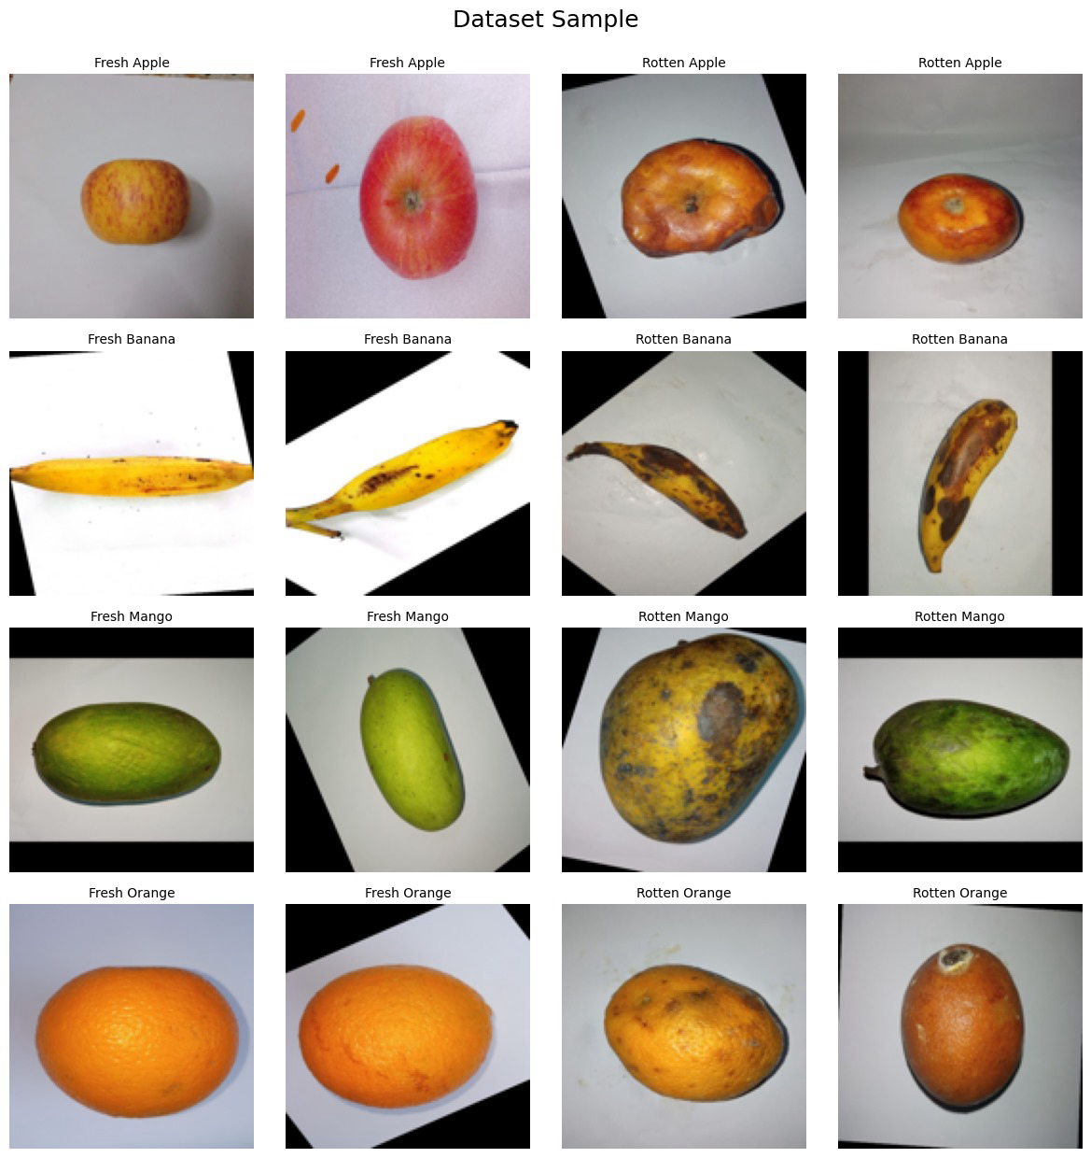
fig .4.2 Dataset sample from FruitVision

CAMERA:-
The 640x480 USB camera with a collapsible cable is a low-cost and compact imaging device suitable for basic image capture tasks. Although it offers a lower resolution compared to advanced Raspberry Pi camera modules, it is still capable of capturing clear and sufficiently detailed images for simple applications like fruit classification under controlled lighting conditions. With its 1/4" CMOS sensor and fixed focus lens, this camera delivers VGA resolution (640×480), which can be effective when used for detecting general features, color, and shape of fruits. The USB 2.0 interface ensures easy plug-and-play compatibility with Raspberry Pi models, as well as PCs and Android devices, making it highly versatile. The collapsible flat cable allows flexible placement and space-saving installation, which is particularly useful in compact or portable setups. Despite its limitations in resolution and field of view, it serves as a suitable and affordable choice for capturing consistent fruit images in lightweight image processing projects.

MobileNetV2 Architecture:-The core of the system: a lightweight deep learning model for image classification/detection.
Steps inside MobileNetV2 block:
- Model Building: Define the architecture of MobileNetV2.
- Model Compilation: Set loss function, optimizer, and metrics.
- Model Evaluation: Test the model on validation/test data to check performance.

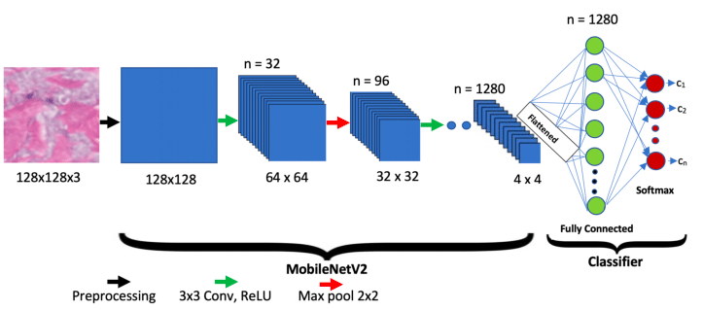
fig 4.3 MobilenetV2 Architecture

MobileNetV2 is a lightweight deep learning model designed for mobile and embedded devices. It's efficient, fast, and works well for tasks like image classification and object detection.

Features

Inverted Residuals
Instead of going from few to many channels (like typical ResNets), it goes from narrow → wide → narrow.Helps keep computation low while still capturing features.

Linear Bottlenecks
The last layer of each block removes the ReLU activation to avoid losing information, especially in low-dimensional spaces.
Depthwise Separable Convolutions
Breaks a standard convolution into two parts:Depthwise conv: One filter per input channel.Pointwise conv (1×1): Combines features across channels.This saves a lot of computation.

MobileNetV2 Architecture - Explained for Fruit Classification

- Lightweight -> fast on low-power devices
- Less memory usage
- Good accuracy
- Easy TensorFlow Lite conversion

This makes it an ideal choice for real-time fruit classification and sorting systems.

Final Output Example:
If the final softmax gives: [0.91, 0.05, 0.03, 0.01], the model predicts: "Fruit: Apple"

RASPBERRY PI:-
The Raspberry Pi 4 Model B is a powerful single-board computer ideal for applications involving image processing, deep learning, and automation. It is equipped with a Broadcom BCM2711 quad-core Cortex-A72 (ARM v8) 64-bit processor running at 1.5GHz, offering significantly higher processing power compared to its predecessors. It comes in multiple RAM variants 2GB, 4GB, and 8GB LPDDR4 allowing users to choose based on the complexity of their project.
For connectivity, it supports dual-band 2.4GHz and 5.0GHz Wi-Fi, Bluetooth 5.0, and Gigabit Ethernet, enabling fast data transfer and remote access capabilities. The board also includes two USB 3.0 ports, two USB 2.0 ports, and dual micro-HDMI ports supporting up to 4K resolution, which is useful for real-time image display and monitoring.
From an image processing perspective, the Raspberry Pi 4B integrates a CSI camera interface, which supports high-quality Raspberry Pi camera modules such as V2 and V3. It also supports USB cameras, expanding its flexibility for different types of vision systems.
The board operates at 5V via USB-C power input, typically drawing 3A during demanding tasks. While it is more power-hungry than earlier models, the performance boost makes it highly suitable for fruit quality detection, classification, and disease identification systems using deep learning models like CNNs.
Overall, the Raspberry Pi 4B offers a perfect balance between performance, connectivity, and cost, making it a robust and scalable platform for real-time fruit image analysis applications.

Monitor
The output from Raspberry Pi (fruit type/quality) is displayed here.The system feedback loop is created for real-time monitoring and updates.

5.HARDWARE SYSTEM DESIGN

5.1 Hardware Resources
Table 5.1. 1: Hardware Requirements of Multiple Fruit Quality Assessment Systems.
Sr. No | Component | Minimum Requirement | Justification | Remark
1 | GPU | Raspberry Pi 4B (Quad-core Cortex-A72) | Required for processing image data and running deep learning models locally. | Sufficient for real-time AI
2 | Camera Module | Raspberry Pi Camera (8MP or higher) | Captures real-time images of fruits for classification. | Compatible with RPi
3 | Power Supply | 5V/3A USB-C Adapter | Provides stable power to the Raspberry Pi and connected peripherals. | Must ensure stable voltage
4 | Storage | 32GB microSD Card (Class 10) | Stores OS, model files, libraries, and logs. | Expandable if needed

5.2 Description of Hardware used:
The hardware used for this project includes the Raspberry Pi 4B as the main processing unit. It features a Quad-core Cortex-A72 processor and is capable of handling real-time image processing and deep learning inference using TensorFlow Lite models. To capture high-resolution images of fruits, a Raspberry Pi Camera Module (8MP or higher) is directly interfaced with the Raspberry Pi through the CSI (Camera Serial Interface) port. For powering the system, a standard 5V/3A USB-C power adapter is used to ensure stable and uninterrupted performance during operation. The storage requirements are fulfilled using a 32GB Class 10 microSD card, which contains the Raspberry Pi OS, Python-based programs, deep learning models, and space for saving captured images and logs. This minimal yet efficient hardware setup ensures low power consumption, compact design, and portability, making it well-suited for real-time fruit quality detection in field or laboratory environments.
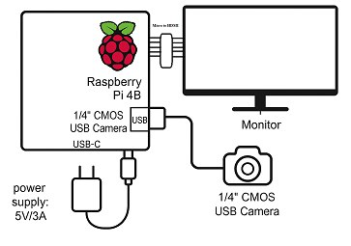
fig 5.2.1 Hardware Design of Multiple Fruit Quality Assessment System.

Power Supply: This component provides the necessary electrical power to operate the entire system.
Raspberry Pi 4: This single-board computer serves as the central processing unit of the system. It runs the software that controls the other components and performs the image processing tasks.
Camera: This device captures images or videos that are then processed by the Raspberry Pi 4.
Monitor: This display device is used to visualize the captured images or the results of the image processing algorithms.
The connections between the components suggest the following flow of data:
The camera captures an image.
The image is transmitted to the Raspberry Pi.
The Raspberry Pi processes the image using appropriate algorithms.
The processed image and results are displayed on the monitor.

5.3 Enclosure design
The enclosure for the fruit quality assessment system is designed to be compact, durable, and lightweight, providing protection to internal components such as the Raspberry Pi 4B, camera module, and power supply unit. The cabinet is constructed using acrylic or ABS plastic, chosen for its lightweight, cost-effectiveness, and insulation properties. The enclosure has a rectangular box-type structure with approximate dimensions of20 cm × 25 cm × 25 cm making it portable and easy to mount on various setups. The front panel includes precise cutouts for the camera lens, USB ports, HDMI output, Ethernet port, and microSD slot, along with labeled indicators for power and processing status

6.SOFTWARE SYSTEM DESIGN

6.1 Software Resources:
- Python
In this project, Python serves as the primary programming language due to its simplicity, extensive library support, and strong community. Python allows seamless integration of various tools and frameworks required for image processing and deep learning. It is used for controlling the Raspberry Pi hardware, capturing fruit images from the connected camera, and executing the logic for preprocessing, feature extraction, and classification. Python also simplifies data handling, model training, and GUI development if required

- Raspberry Pi OS
The fruit classification and quality grading system was deployed on a Raspberry Pi 4 Model B using the official Raspberry Pi OS (64-bit), which comes with Python 3.11 pre-installed. The 64-bit operating system was selected to ensure compatibility with TensorFlow Lite and to fully utilize the Raspberry Pi’s hardware capabilities, especially the 4GB RAM. This architecture supports efficient execution of machine learning models and image processing tasks, enabling smooth and real-time fruit prediction. The use of the 64-bit OS also ensures better performance, library support, and future scalability for more advanced features such as cloud logging, model upgrades, or integration with additional sensors.

- OpenCV
OpenCV (Open Source Computer Vision Library) is utilized for real-time image processing tasks. It is used to capture live images of fruits, perform preprocessing operations such as resizing, filtering, noise reduction, color correction, background removal, and segmentation. These operations enhance the input quality and ensure that the important features of the fruit such as shape, color, and texture are accurately extracted. OpenCV also helps in drawing contours, measuring dimensions, and visualizing output results.

- TensorFlow
TensorFlow, an open-source deep learning framework, is used to develop and deploy the classification model. A Convolutional Neural Network (CNN) is trained using labeled fruit image datasets to identify the fruit type, quality grade, or disease symptoms. The trained model is then imported into the Raspberry Pi using TensorFlow Lite for real-time inference. TensorFlow ensures accurate prediction and fast processing, making it ideal for embedded AI applications such as this fruit quality assessment system.
6.2 Algorithm

1.Start:

2.Fruit Identification and Classification: The main goal is to build a system that can identify and classify different fruits.

3.Data Preparation: Involves collecting and organizing the dataset and labeling the data correctly for training the model.

4.Model (MobileNet_V2): The MobileNet_V2 architecture is chosen due to its efficiency and suitability for lightweight devices. The model is trained using the prepared data.

5.Model Evaluation Paths:
.h5 Model Evaluation: The trained model is saved in .h5 format and evaluated for accuracy and performance.
.tflite Model Evaluation: The same model is also converted to .tflite format for TensorFlow Lite, which is optimized for mobile and embedded devices, and then evaluated.

6.Deployment (Raspberry Pi 4B): After evaluation, the model is deployed on a
Raspberry Pi 4B, a compact and cost-effective device ideal for running lightweight AI models in real-time applications.

7.End:

6.3 Flowchart

Training Dataset and fruit Label
Fruit 1 with label
Fruit 2 with label
Fruit 3 with label
Fruit 4 with label
MobileNetV2 Training Model
Optimization of Model
Training weight file
Real time images camera feed
Detecting fruit type and freshness

fig 6.3.1 Flow Chart of Multiple Fruit Quality Assessment System.

7.RESULTS AND PERFORMANCE EVALUATION
7.1 Photo of the Project with Enclosure:
The result of the Multiple Fruit Quality Assessment System would be to accurately classify fruits into their respective categories (e.g., Apple, Banana, Orange,Mango) and assess their quality (e.g., fresh, rotten). The system handles a variety of fruit types and conditions, and provides reliable and consistent results.

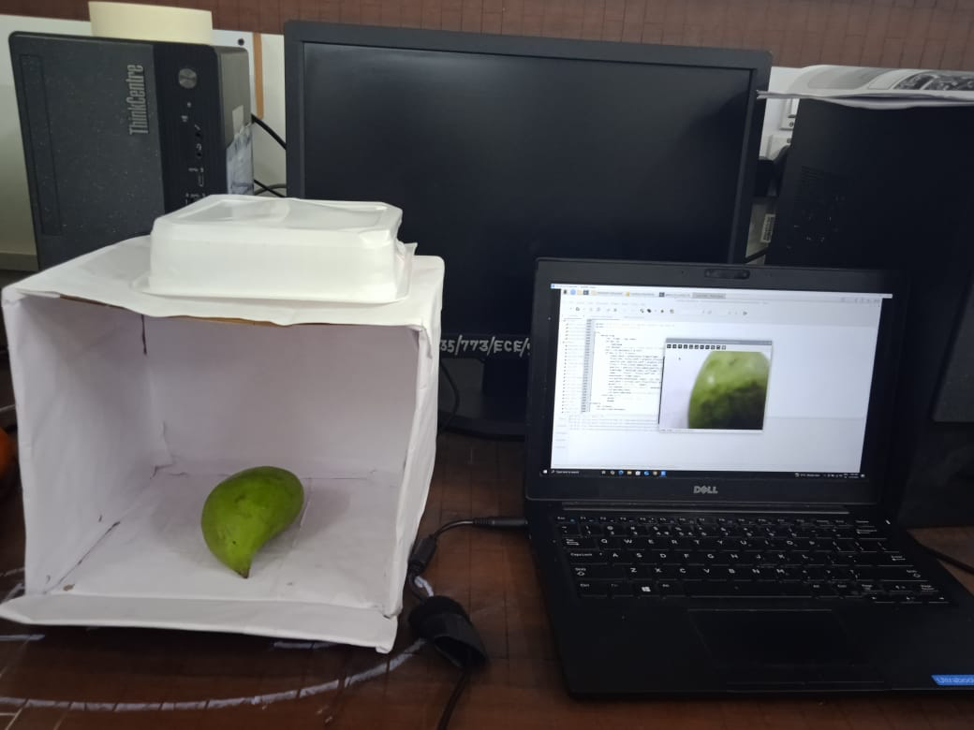
fig 7.1 Photo of Multiple Fruit Quality Assessment System with enclosure

7.2 Photo of the Project without Enclosure Highlighting all the Hardware Modules:
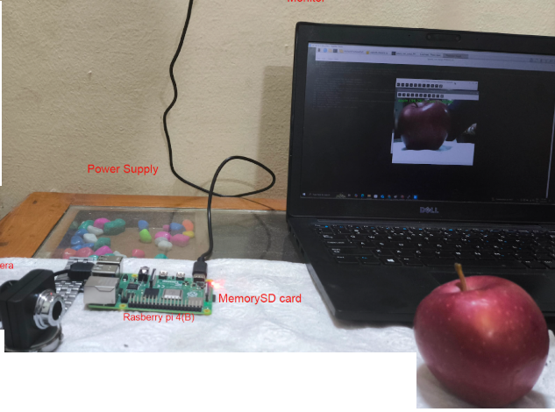
fig 7.2 Photo of Multiple Fruit Quality Assessment System without enclosure

7.3 Operating Procedure of the Multiple Fruit Quality Assessment System:
1.Connect the raspberry pi to the power supply and other peripherals.
2.Insert SD card in raspberry pi with os and model.
3.connect camera,display,keyboard and mouse.
4.boot the raspberry pi,power on the board, wait for the desktop to load.
5.open project directory,Navigate to the folder containing the python and mobileNetV2 Model.
6.open the terminal and run python scripts.
7.live fruit detection and classification begins.the system activates webcam,detects fruits,and classification is done in real time.
8.output display,fruit is fresh and rotten with their accuracy.
9.Exit the program shut down the system.

7.4 Necessary Precautions:
Ensure stable power supply to the Raspberry Pi (5V, 2.5A or higher) to avoid sudden shutdowns.
Do not unplug the camera while the system is running to prevent software crashes.
Place fruits within proper camera range and alignment to ensure accurate classification.
Avoid touching the camera lens or shaking the setup during prediction to prevent misclassification.
Do not obstruct the lighting near the webcam; maintain consistent illumination.
Ensure the enclosure is ventilated, especially during continuous operation, to prevent overheating.
Check Wi-Fi or network connectivity if logging to Google Sheets or uploading to Drive.
Keep the system in a clean, dust-free environment to maintain lens and fan efficiency.
Do not shut down Raspberry Pi abruptly; always use safe shutdown (sudo shutdown now) to avoid SD card corruption.
7.5 Results:

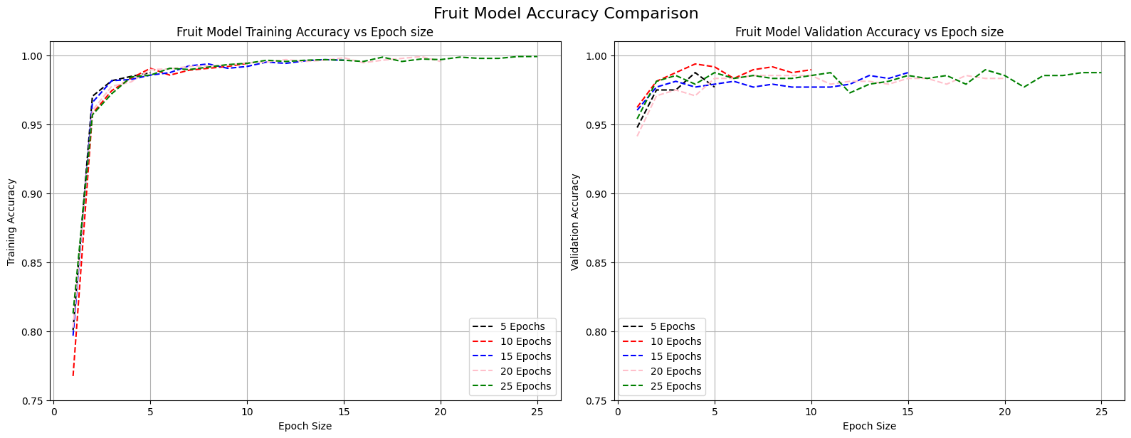
a b
fig. 7.5.1 Accuracy curves for MobileNetV2 models across different epochs:
a –training accuracy curves; b –validation accuracy curves

Training Accuracy vs Epoch Size
This plot shows how the training accuracy improves over epochs. All models exhibit rapid accuracy gains in the initial epochs. After around 10 epochs, the accuracy begins to plateau, approaching nearly 100%. However, shorter training durations like 5 or 10 epochs slightly underperform compared to longer training cycles such as 20 or 25 epochs.
Validation Accuracy vs Epoch Size
The validation accuracy shows that while accuracy initially improves, overtraining beyond 20 epochs results in minimal or no gain — in fact, it slightly fluctuates, hinting at potential overfitting beyond the 20th epoch. The model trained for 20 epochs achieves a strong balance between performance and generalization.

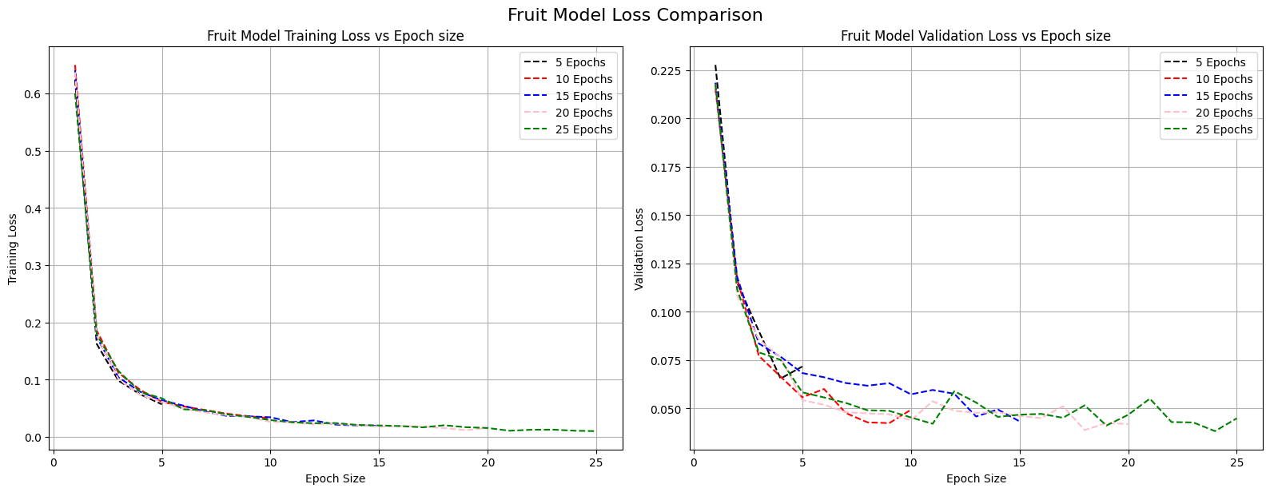
a b
fig. 7.5.2 Loss curves for MobileNetV2 Fruit model across different epochs:
a –training loss curves; b –validation loss curves
The training loss sharply decreases within the first few epochs and continues to decline steadily, nearing zero as epochs increase. This indicates that the model is effectively learning and minimizing the error on the training data across all training durations.
The validation loss reaches its minimum around 20 epochs. Although it remains low for 25 epochs, it exhibits some fluctuations, suggesting the onset of overfitting or noise. This supports the idea that 20 epochs offer the most stable and generalized performance.
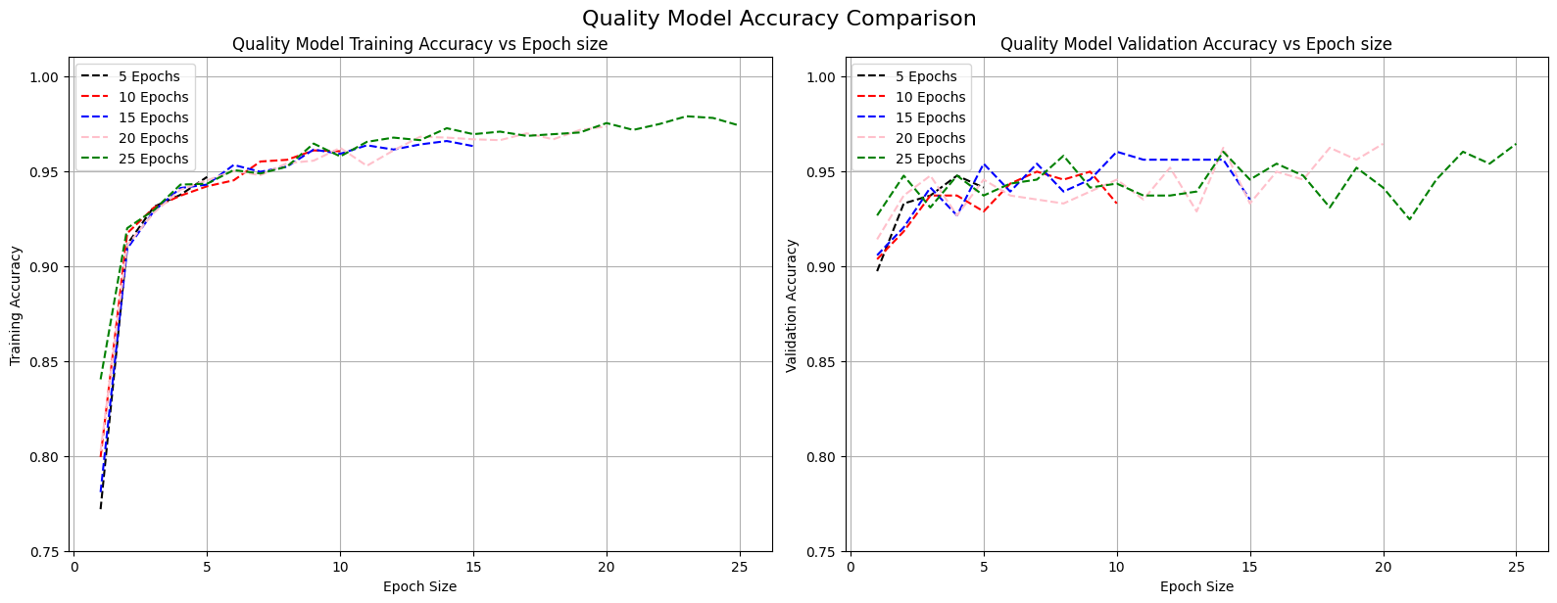
a b
fig. 7.5.3 Accuracy curves for MobileNetV2 Quality model across different epochs:
a –training accuracy curves; b –validation accuracy curves
The training accuracy plot shows a consistent increase for all epoch settings. It starts around 85% and climbs steadily, plateauing near 97–98% after 20 epochs. The gain beyond 20 epochs is marginal, indicating diminishing returns with prolonged training.
Validation accuracy reflects the model's generalization ability. Here, models trained for 15 and 20 epochs maintain relatively stable and high performance (~95%), while the 25-epoch curve begins to fluctuate slightly, hinting at mild overfitting or instability. Shorter durations (5–10 epochs) are less consistent, suggesting underfitting.

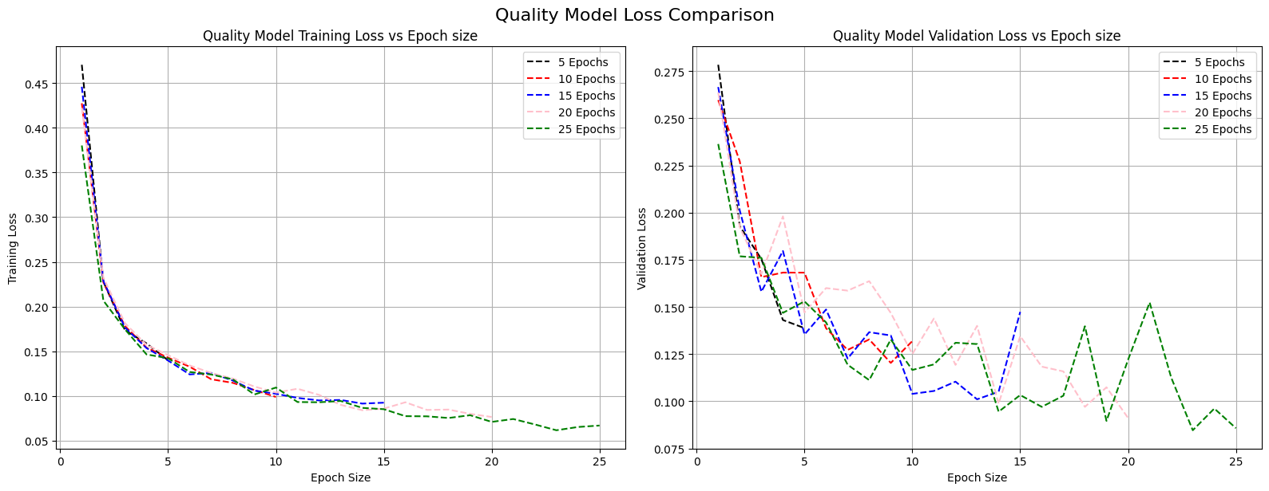
fig. 7.5.4 Loss curves for MobileNetV2 Quality models across different epochs:
a –training loss curves; b –validation loss curves.

The training loss steadily decreases as epochs increase. It shows a smooth and sharp decline in the early stages and gradually levels off near 0.08–0.1 beyond 15 epochs, confirming effective learning from the training data.
Validation loss trends downward overall, with the lowest and most stable values observed around 20 epochs. The 25-epoch curve becomes erratic, which may suggest overfitting. Models trained for 5–10 epochs show higher and more variable loss values, reflecting less robust generalization.

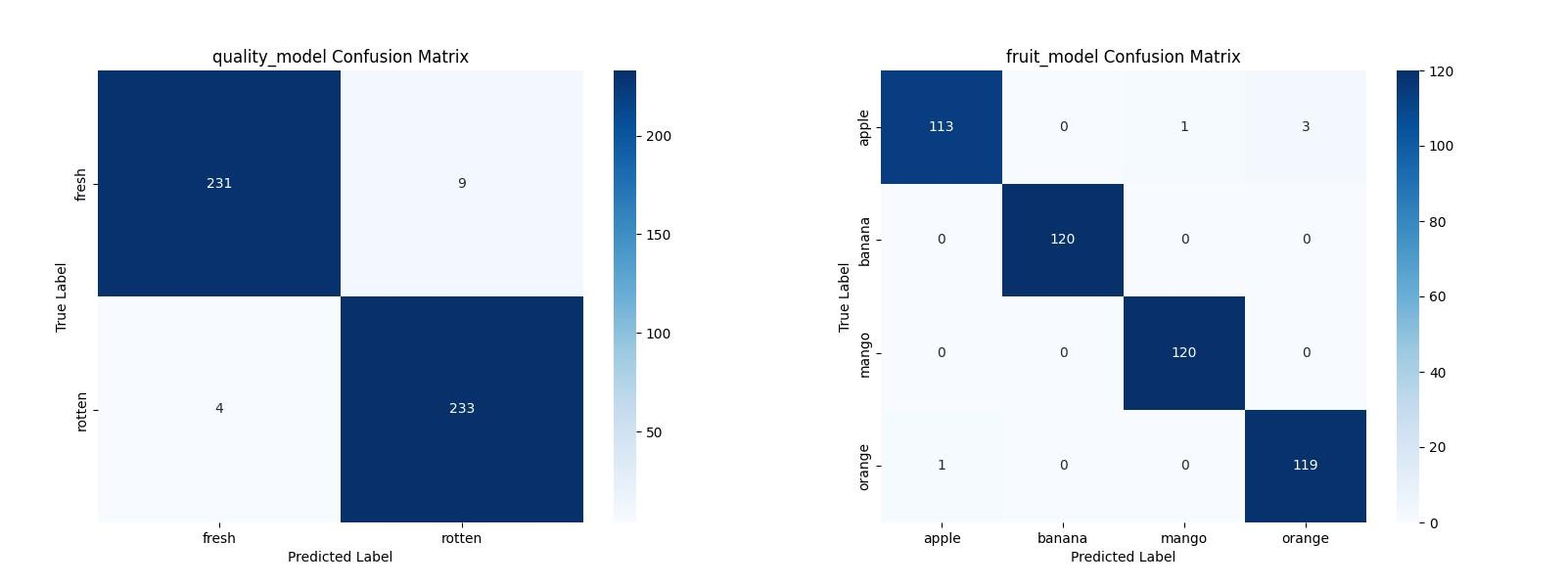
a b
fig. 7.5.5 Confusion matrix obtained for the MobileNetV2 models:
a - Fruit model confusion matrix; b -Quality model confusion matrix

In the quality model confusion matrix, the rows represent the true labels (fresh or rotten), while the columns represent the predicted labels. The model correctly identified 231 out of 240 fresh fruit images, misclassifying only 9 as rotten. Similarly, it correctly predicted 233 out of 237 rotten fruits, with just 4 mistakenly labeled as fresh. These low misclassification counts indicate that the model is highly reliable in distinguishing between fresh and rotten fruit, reinforcing the high precision and recall scores seen earlier.
In the fruit model confusion matrix shows the classification performance for four fruit classes: apple, banana, mango, and orange. The model performs almost flawlessly for banana and mango, correctly classifying all 120 images in each class with zero misclassifications. Apple classification also shows strong performance, with 113 out of 117 correctly identified, and only a few misclassified as mango (1) and orange (3). Orange is similarly well-predicted, with just one image incorrectly identified as apple. The overall confusion matrix shows minimal overlap between classes, confirming that the fruit model distinguishes between fruit types with very high accuracy and minimal confusion.

Table 7.5.6 Performance Parameter of MobileNetV2 models
a -Fruit model; b -Quality model
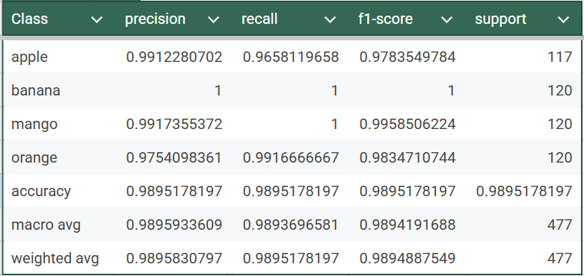
a
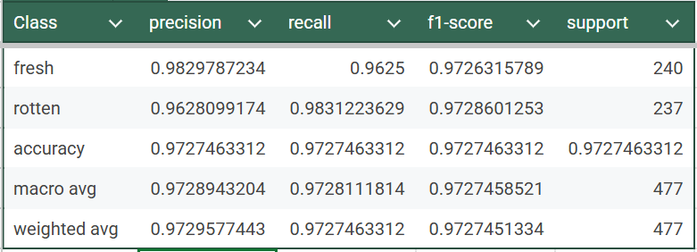
b
The tables display the classification reports for two deep learning models: one designed for fruit type classification (apple, banana, mango, orange), and the other for assessing fruit quality (fresh or rotten). These reports provide a detailed evaluation of each model's performance using standard classification metrics such as precision, recall, F1-score, and support (the number of actual instances for each class in the test set).
For the fruit classification model, the performance is remarkably high across all classes. Banana and mango are classified with near-perfect precision, recall, and F1-scores—banana achieves a flawless 1.0 score in all metrics, indicating that every banana image was correctly identified with no false positives or negatives. Mango follows closely, with an F1-score of 0.9958, which shows a similarly outstanding classification rate. While apple and orange have slightly lower scores, particularly in recall (apple: 0.9658, orange: 0.9917), their overall F1-scores remain above 0.97, suggesting very few misclassifications. The overall accuracy of the model is approximately 98.95%, with macro and weighted averages of precision, recall, and F1-score also around the same value, indicating that the model performs consistently well across all fruit categories, without being biased toward any particular class.
The second report pertains to the fruit quality classification model, which categorizes fruits as either fresh or rotten. This model also shows excellent results, though slightly lower than the fruit classifier. Fresh fruits are identified with a precision of 0.9829 and a recall of 0.9625, while rotten fruits show a recall of 0.9831 but a slightly lower precision of 0.9628. This indicates that the model is very good at identifying rotten fruits, but occasionally mislabels a fresh fruit as rotten. Despite this, the F1-scores for both classes remain very high (around 0.9726), and the overall model accuracy is about 97.27%. Both macro and weighted averages align closely with this figure, confirming that the model performs reliably across both quality categories.
Both models are highly accurate and demonstrate excellent classification performance. The fruit classifier slightly outperforms the quality classifier, but both are well-suited for real-time deployment applications, such as automated fruit grading systems on edge devices like Raspberry Pi. These results validate that training the models for 20 epochs was a well-balanced choice, as reflected in the consistency of high accuracy and minimal loss in earlier comparative plots.
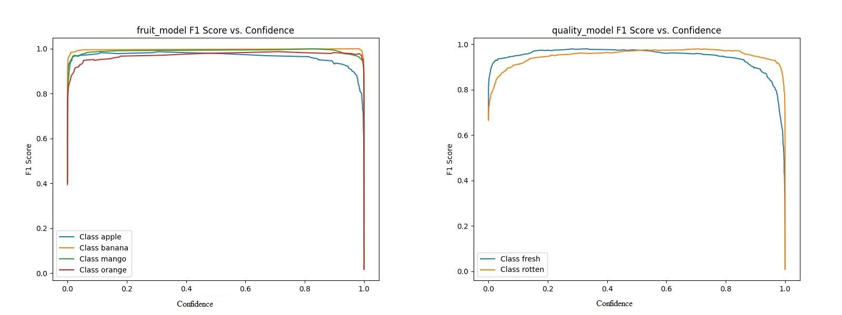
a b
fig 7.5.7 Curves of f1 - confidence for MobilenetV2 models across distinct classes:
a -Fruit model; b -Quality model
The figure showcases two line plots that illustrate the relationship between F1 Score and Confidence for both the fruit classification model (on the left) and the quality classification model (on the right). These plots are essential for understanding how the models' prediction confidence influences their classification performance.
In the fruit model F1 score vs. confidence plot, four lines represent the four fruit classes: apple, banana, mango, and orange. As the confidence threshold increases from 0 to 1 along the x-axis, the F1 scores initially rise sharply and stabilize close to 1 for most classes. Mango and banana maintain near-perfect F1 scores throughout most thresholds, indicating strong consistency and confidence in predictions. Apple and orange also show high F1 scores, but apple slightly drops at higher thresholds, possibly due to a few uncertain predictions being filtered out as confidence increases. The curves are smooth and peak between thresholds of 0.3 to 0.9, demonstrating that the model performs reliably across a wide range of confidence levels, with minimal risk of under- or over-prediction.
On the quality model F1 score vs. confidence plot, we observe the performance of the model in classifying fresh and rotten fruits. Both classes exhibit a steep initial rise in F1 score, quickly reaching values close to 1, especially for fresh samples. The rotten class performs slightly less consistently than fresh but still maintains a high score across most of the threshold range. At very high thresholds (close to 1.0), a sharp decline is observed in both curves, indicating that the model starts rejecting even correct predictions due to overly strict confidence filtering.
Together, these plots highlight that both models are highly effective and confident in their classifications. They also help determine optimal thresholds where the model maintains high precision and recall, making them crucial for fine-tuning real-world deployment—particularly in systems where confident decision-making is critical, such as automated fruit sorting and grading.

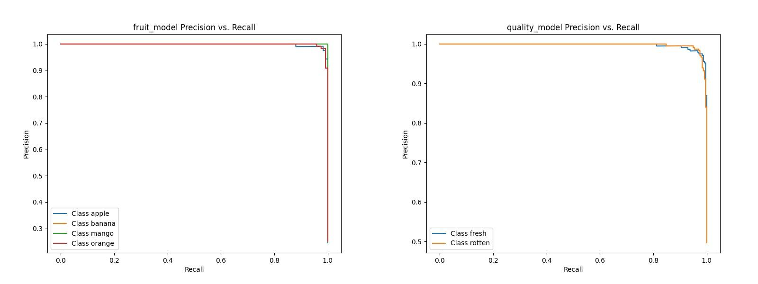
a b
fig 7.5.8 Curves of Precision - Recall for MobilenetV2 models across distinct classes:
a -Fruit model; b -Quality model

The provided Precision-Recall (PR) curves offer a clear picture of the model performance for both fruit type and fruit quality classification tasks. On the left, the fruit classification model shows four distinct curves representing the classes: apple, banana, mango, and orange. Each of these classes demonstrates remarkably high precision across almost the entire range of recall values. This indicates that the model is making very few false positive predictions, and when it does predict a class with confidence, it is usually correct. As recall increases, there is only a minimal drop in precision, suggesting that the model can correctly identify a high proportion of true positives without significantly compromising on precision. The curves are nearly flat and remain close to the top of the graph, reflecting near-perfect classification capabilities. This is especially important in real-time systems where both speed and accuracy are critical, and any misclassification can affect downstream tasks or user trust.
On the right, the PR curves for the quality classification model, which categorizes fruit as either fresh or rotten, show similarly strong performance. The curve for the "fresh" class is almost ideal, maintaining precision near 1.0 across all levels of recall. This means the model is highly reliable when it labels a fruit as fresh. The "rotten" class, while also showing strong results, exhibits a slight drop in precision as recall approaches 1.0. This suggests that while the model is effective at identifying most rotten fruits, there are a few cases where it may mistakenly classify fresh fruits as rotten. However, this decline is modest and does not significantly detract from the overall performance.
Taken together, these curves highlight the robustness and reliability of the models at this training stage. The fruit classification model handles multi-class predictions with excellent balance, and the quality classification model distinguishes between fresh and rotten fruits with a high degree of confidence. These visualizations justify the model’s deployment at this point, likely epoch 20, as they show a well-balanced performance with minimal overfitting or underfitting, making it suitable for real-world applications.

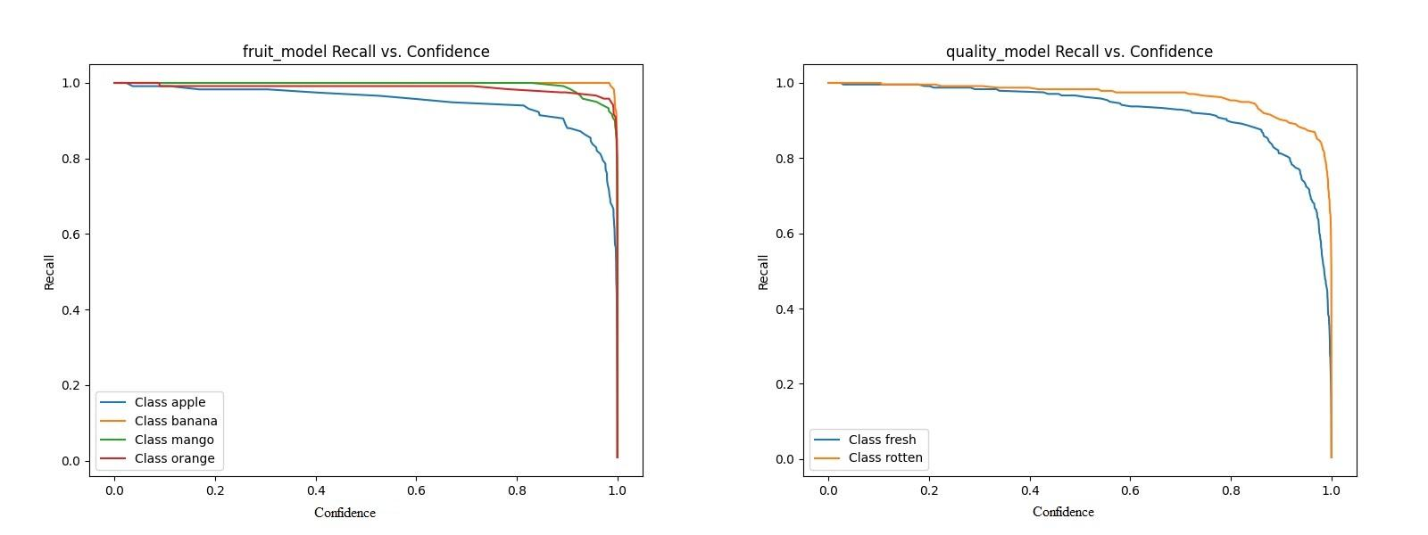
fig 7.5.9 Curves of Recall - Confidence for MobilenetV2 models across distinct classes:
a -Fruit model; b -Quality model

The Recall vs. Confidence plots for both the fruit classification and quality classification models provide further insights into how each model behaves with respect to prediction certainty. On the left, the fruit model's recall for each class—apple, banana, mango, and orange—is plotted against varying confidence thresholds. The curves reveal that as the confidence threshold increases, recall gradually decreases, which is expected. The "apple" class shows the most noticeable drop in recall as confidence increases, indicating that while the model is good at detecting apples, it becomes more conservative (i.e., misses more apples) when higher confidence is required for a prediction. In contrast, the classes "banana," "mango," and "orange" retain high recall values even at higher thresholds, which suggests the model is highly confident in identifying these fruits correctly.
On the right, the recall vs. confidence curves for the quality model show a similar but more balanced pattern. Both "fresh" and "rotten" classes start with near-perfect recall at low confidence thresholds and experience a gradual decline as the threshold increases. Notably, the "rotten" class maintains higher recall at elevated confidence levels compared to the "fresh" class. This suggests that the model is more consistent in identifying rotten fruits even when it is required to be more confident, whereas the detection of fresh fruits becomes more conservative at higher thresholds.
These plots are essential for understanding how the models might perform in real-world deployments where a confidence threshold is often set to avoid false positives. The fruit model demonstrates robust generalization across classes, though slight caution is advised for apple detection at higher thresholds. The quality model shows balanced and reliable performance, with a slight edge in consistency for identifying rotten fruits. Altogether, these curves support the rationale for deploying the model at the selected training stage, as they reflect high confidence and recall harmony, making the models practical for real-time applications.
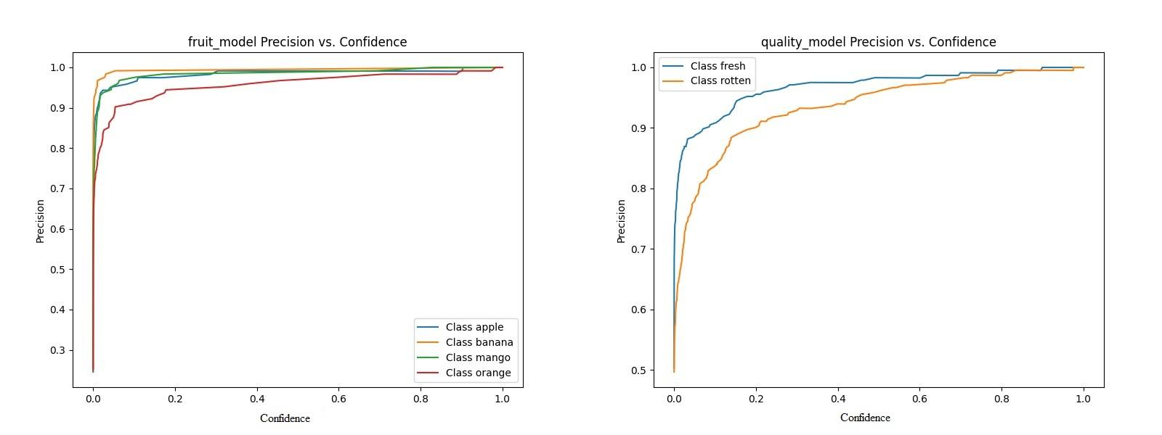
a b
fig 7.5.10 Curves of Precision - Confidence for MobilenetV2 models across distinct classes:
a -Fruit model; b -Quality model

The Precision vs. Recall curves for both the fruit classification and quality classification models offer deeper insights into their ability to balance the trade-off between detecting all relevant instances (recall) and minimizing false positives (precision). On the left-hand side, the fruit model shows curves for each fruit class: apple, banana, mango, and orange. All curves begin with high precision and gradually decline as recall increases. This behavior reflects the typical trade-off where increasing recall slightly sacrifices precision. Notably, the precision for all four fruit classes remains impressively close to 1.0 across most recall values, demonstrating the model’s high accuracy in distinguishing between different fruits even as it attempts to detect more instances. The curves only show slight deviations near the highest recall values, suggesting that a few misclassifications occur when the model tries to capture every possible instance, but overall, the model maintains strong precision throughout.
On the right-hand side, the quality model's performance is shown for the "fresh" and "rotten" classes. Both classes exhibit extremely high precision—nearly flat curves close to 1.0—throughout almost the entire range of recall. This indicates that the model is highly reliable in classifying fruit quality with very few false positives. However, a small drop is visible toward the extreme right of the graph, particularly for the "rotten" class, which implies a slight compromise in precision when recall reaches its maximum. This minor dip is acceptable in practical terms and shows that the model only struggles slightly when it tries to identify every single instance of rotten fruits.
In both cases, these curves confirm that the models are highly effective and generalize well across classes. The flat and high-lying precision-recall curves signify that the selected training epoch achieves a solid balance, minimizing the risk of overfitting or underfitting. These results strongly support the reliability and robustness of the fruit and quality classification models, making them suitable for deployment in real-world scenarios where accurate and confident predictions are critical.
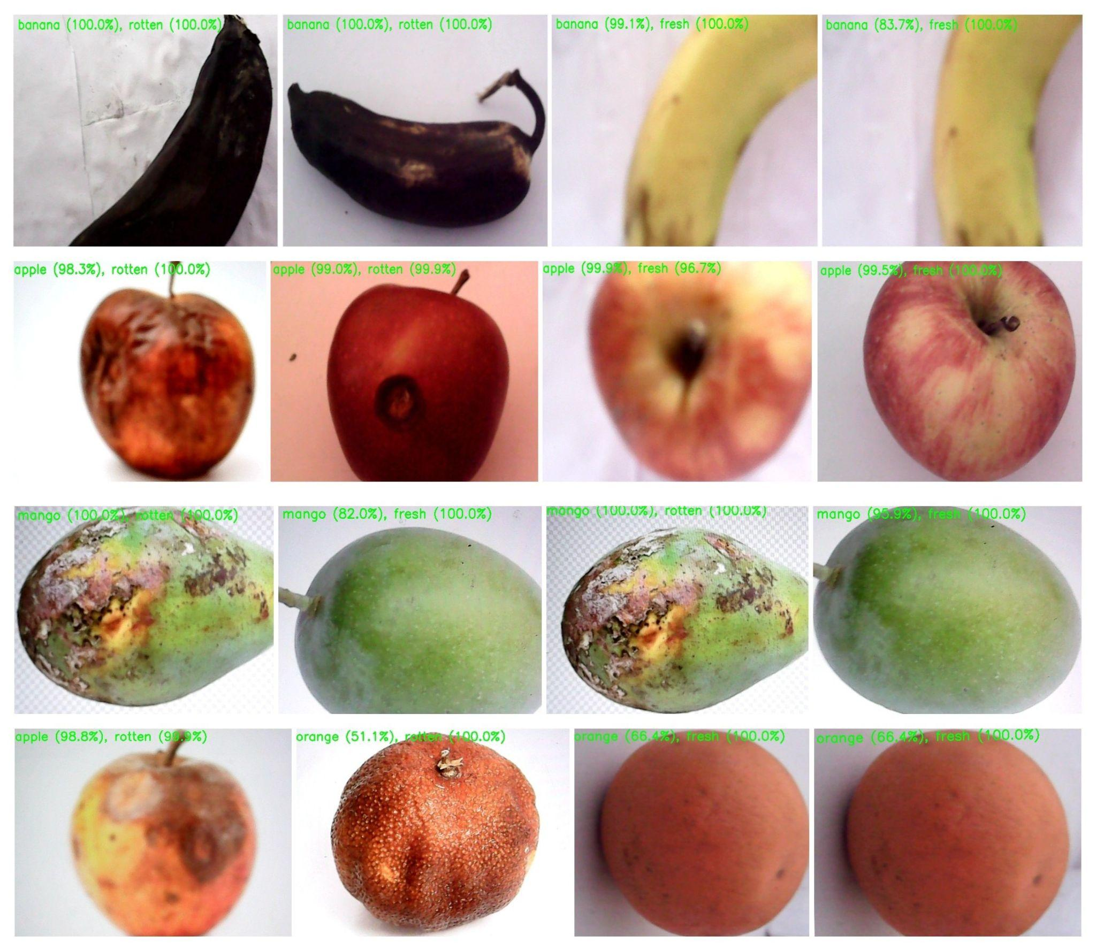
fig. 7.5.11 Real-Time Fruit Classification and Quality Assessment Results
The real-time predictions generated by the deployed fruit classification and quality assessment system on a Raspberry Pi. Each fruit sample is captured using a connected camera, and the model processes the image to predict both the fruit type (e.g., apple, banana, mango, orange) and its quality status (fresh or rotten). The results are overlaid on each image, displaying the predicted fruit type and quality along with their respective confidence scores in parentheses.
The system demonstrates high accuracy and reliability across various fruit categories. For instance, rotten bananas are detected with complete confidence (100.0%), and fresh apples are correctly classified with high confidence (up to 99.5%). Similarly, mangoes and apples in both fresh and rotten conditions show consistent and accurate predictions.
However, a slight drop in classification confidence is observed in some cases like oranges, where the model predicts "orange (51.1%), rotten (100.0%)" and "orange (66.4%), fresh (100.0%)". This suggests that certain fruit types with ambiguous surface textures or degraded quality may introduce challenges in prediction, indicating scope for further model improvement or dataset balancing.
These results confirm the model’s ability to perform real-time fruit recognition and grading effectively, making it suitable for practical applications such as automated sorting and quality assessment in agriculture and food industries.

table 7.5.12 Comparison of models and backbone on accuracy
Backbone | Dataset | Accuracy
MobileNetV2 (proposed) | FruitVision | Fruit: 98.11  Quality: 95.81
  Custom CNN[1]
  44,406 fruit images
  88.6
Custom CNN[14] | 2000 Apple Images | 98.0
  GoogLeNet
  Jackfruit growth stage images
  90.0

8.CONCLUSION AND FUTURE SCOPE
8.1 Conclusion
The Multiple fruit quality assessment system Project successfully demonstrates an end-to-end pipeline for classifying fruit types and evaluating their quality using deep learning. Leveraging MobileNetV2 and training on a well-organized dataset of 3200 images, the project achieves reliable performance across multiple epochs, with evaluation metrics including accuracy, precision, recall, and F1-score.
By converting the models into TensorFlow Lite (TFLite) format and deploying them on a Raspberry Pi 4B, the system showcases real-time image capture, classification, and result annotation directly from a webcam. The Raspberry Pi environment, optimised with a virtual environment (fruitenv), proves to be capable of running lightweight deep learning inference, making the project suitable for practical applications in smart agriculture, fruit sorting lines, or quality control systems.
The modular design, clear dataset structure, and comprehensive evaluation make the system scalable, easy to maintain, and ready for future enhancements such as multi-class grading, integration with IoT devices, or mobile deployment

8.2 Future Scope
1. Expand Dataset
The current dataset is limited in terms of fruit variety and environmental diversity. To improve model robustness, more fruit types such as grapes, watermelon, and papaya should be included. Images should also be collected under different lighting conditions (e.g., sunlight, artificial light, low-light) and backgrounds to make the model perform well in varied real-world scenarios. Advanced techniques like data augmentation using Keras or Albumentations, and even synthetic data generation using Generative Adversarial Networks (GANs), can be used to enrich the dataset further.

2. Real-Time Detection
Currently, the system is capable of classifying one fruit per frame. In future versions, object detection models like YOLOv8, SSD, or EfficientDet can be used to detect and classify multiple fruits simultaneously in a single image or live video stream. This would involve training on annotated datasets with bounding boxes. Integration with OpenCV for real-time webcam inference will help make this system usable in live sorting environments, such as on conveyor belts or grading lines.

3. Mobile App Deployment
To make the solution more portable and user-friendly, a mobile application can be developed using platforms like Android Studio or Flutter. TensorFlow Lite models can be integrated into the app, allowing real-time fruit classification directly through a smartphone camera. This approach will make the system accessible to farmers and vendors who may not have access to a Raspberry Pi or laptop. Offline capabilities can be ensured by bundling the models inside the app.

4. Cloud Integration
The current system logs results locally using CSV files and Google Sheets. In the future, integration with Firebase or AWS can allow real-time data logging, visualization, and centralized monitoring. Captured images and predictions can be stored in Firebase Storage or AWS S3, while metadata and logs can be managed using Firestore or DynamoDB. Web dashboards using tools like React, Streamlit, or Dash can display analytics and prediction history for tracking trends.

5. Hardware Automation
To eliminate manual fruit sorting, hardware automation can be introduced. Raspberry Pi can control servo motors or actuators to push fruits into respective bins based on their classification results. The flow would involve capturing the fruit image, predicting its class and quality, and activating the appropriate hardware mechanism to sort the fruit. Simple IR or ultrasonic sensors can be used to detect fruit positions before triggering the sorting mechanism.

6. Edge AI Optimization
Although TensorFlow Lite already provides optimized models, further speed improvements can be made using quantization, pruning, and distillation. Quantization reduces model size by converting float32 weights to int8, making it suitable for low-power devices. Pruning removes unnecessary network connections, improving efficiency. These optimizations will help run models faster on edge devices like the Raspberry Pi, Jetson Nano, or Coral TPU without sacrificing accuracy.

7. Voice Feedback
To make the system accessible to more users, especially those with visual impairments, multilingual voice feedback can be added. This feature can announce the predicted fruit type and its quality along with confidence score in languages like Marathi, Hindi, and English. Libraries such as pyttsx3, gTTS, or platform-specific TTS APIs can be used. This can also help in noisy environments where visual feedback may be missed.

8. Explainable AI (XAI)
Understanding why a model makes a particular prediction is essential for building trust. Grad-CAM can be used to generate heatmaps that show which areas of the image contributed most to the classification. These visual explanations can be shown alongside the prediction results in the app or interface, allowing users to verify that the model is not making random or biased predictions. Other tools like LIME or SHAPE can also be used for deeper interpretability.

9.BILL OF MATERIALS

Table 9.1 Bill of material

Sr.no | Component | Component Specification | Amount in Rs
1 | Raspberry Pi 4 Model B (4GB RAM) | Quad-core Cortex-A72 processor, 8GB RAM, dual-display support, USB ports, Ethernet, Wi-Fi, Bluetooth. | ₹5,500
2 | 32GB MicroSD Card (Class 10) | 32GB high-speed flash memory suitable for OS and data storage. | ₹500
3 | 640x480 USB Camera with Collapsible Cable | VGA 640×480 pixels, suitable for basic image capture tasks.  1/4" CMOS sensor for clear image acquisition under proper lighting. | ₹800
4 | 5V DC Power Supply for Raspberry Pi | A 5V DC power supply to power the Raspberry Pi and other components. | ₹600
 | Total |  | ₹7400

10.REFERENCES

- Sathyadevan, S., Balakrishnan, A. K., Arya, S., & Raghunath, S. A., “Identifying moving bodies from CCTV videos using machine learning techniques,” First International Conference on Networks & Soft Computing (ICNSC), pp. 151–157, 2014.
https://doi.org/10.1109/cnsc.2014.6906721
- Gelana, F., & Yadav, A., “Firearm Detection from Surveillance Cameras Using Image Processing and Machine Learning Techniques,” Smart Innovations in Communication and Computational Sciences, pp. 25–34, 2018. https://doi.org/10.1007/978-981-13-2414-7_3
- Anishchenko, L., “Machine learning in video surveillance for fall detection,” 2018 Ural Symposium on Biomedical Engineering, Radioelectronics and Information Technology (USBEREIT), pp. 99–102, 2018. https://doi.org/10.1109/usbereit.2018.8384560
- Abdel-Raouf, A., Sheta, A., Baareh, A., & Rausch, P., “Barcode-less Fruits Classification Using Deep Learning,” IAES International Journal of Artificial Intelligence, vol. 13, no. 3, pp. 3211–3217, 2024. https://doi.org/10.11591/ijai.v13.i3.pp3211-3217
- Ayman, Y., ElShabasy, N. H., & Nazih, N., “A Deep Learning Approach for Fruit Recognition and Nutrition Detection,” International Telecommunications Conference (ITC-Egypt), 2024. https://www.semanticscholar.org/paper/A-Deep-Learning-Approach-for-Fruit-Recognition-and-Ayman-ElShabasy/b2d35b948f15ced267b376d448ed63c948149cb2
- Yoon, S., Cho, Y., & Ahn, T. I., “Melon Fruit Detection and Quality Assessment Using Generative AI-Based Image Data Augmentation,” arXiv preprint, 2024.
https://arxiv.org/abs/2407.10413
- Agrawal, V. D., Barhate, H., Waghmare, H., Bhattad, K., & Shelke, S. D., “Fruit (Orange) Quality Inspection using Fully Convolutional Network,” MIT Art, Design and Technology School of Computing International Conference, 2024.
https://colab.ws/articles/10.1109/mitadtsocicon60330.2024.10575502
- Sirisha, B. L., Nayak, B. J., Sandhya, B. S., Rao, J., & Devisri, M., “Fruit Quality Detection Using Deep Learning for Sustainable Agriculture,” International Conference on Recent Advances in Electrical, Electronics, Ubiquitous Communication, and Computational Intelligence (RAUCCI), 2024. https://www.researchgate.net/publication/381396320_Fruit_Quality_Detection_Using_Deep_Learning_for_Sustainable_Agriculture
- K. P, N. S, N. N. S, & Prabhu, A., “Deep Analysis: Apple Fruit Disease Detection Using Deep Learning,” IEEE International Conference on Information Technology, Electronics and Intelligent Communication Systems (ICITEICS), 2024. https://www.researchgate.net/publication/383314345_Deep_Analysis_Apple_Fruit_Disease_Detection_Using_Deep_Learning
- Karki, S., Basak, J., Tamrakar, N., Deb, N. C., Paudel, B., Kook, J., Kang, M., Kang, D. Y., & Kim, H.-t., “Strawberry Disease Detection Using Transfer Learning of Deep Convolutional Neural Networks,” Scientia Horticulturae, vol. 332, Article 13241, 2024. https://www.sciencedirect.com/science/article/abs/pii/S030442382400400X
- Krishnan, S., Pandiyan, M. K., Chandran, R. R., & Devaraj, D., “Utilizing Deep Learning via Computer Vision for Agricultural Production Quality Control: Jackfruit Growth Stage Identification,” Engineering Research Express, vol. 6, no. 3, Article 035213, 2024. https://www.researchgate.net/publication/382372446_Utilizing_deep_learning_via_computer_vision_for_agricultural_production_quality_control_jackfruit_growth_stage_identification
- Piza, E. L., Caplan, J. M., & Kennedy, L. W., “Analyzing the Influence of Micro-Level Factors on CCTV Camera Effect,” Journal of Quantitative Criminology, vol. 30, no. 2, pp. 237–264, 2013. https://doi.org/10.1007/s10940-013-9202-5
- Bhatti, M. T., Khan, M. G., Aslam, M., & Fiaz, M. J., “Weapon Detection in Real-Time CCTV Videos Using Deep Learning,” IEEE Access, vol. 9, pp. 34366–34382, 2021.
https://doi.org/10.1109/access.2021.3059170
- Hosny, K. M., Kassem, M. A., & Foaud, M. M., “Skin Cancer Classification Using Deep Learning and Transfer Learning,” 2018 9th Cairo International Biomedical Engineering Conference (CIBEC), pp. 90–93, 2019. https://doi.org/10.1109/CIBEC.2018.8641762
- Pardamean, B., Cenggoro, T. W., Rahutomo, R., Budiarto, A., & Karuppiah, E. K., “Transfer Learning from Chest X-ray Pre-trained Convolutional Neural Network for Learning Mammogram Data,” Procedia Computer Science, vol. 135, pp. 400–407, 2018. https://doi.org/10.1016/j.procs.2018.08.190
- Siegel, R. L., Miller, K. D., Fuchs, H. E., & Jemal, A., “Cancer Statistics, 2022,” CA: A Cancer Journal for Clinicians, vol. 72, no. 1, pp. 7–33, 2022. https://doi.org/10.3322/caac.21708
- Herman, H., Cenggoro, T. W., Susanto, A., & Pardamean, B., “Deep Learning for Oil Palm Fruit Ripeness Classification with DenseNet,” International Conference on Information Management and Technology (ICIMTech), pp. 116–119, 2021. https://doi.org/10.1109/ICIMTech53080.2021.9534988
- Harsawardana et al., “AI-based Ripeness Grading for Oil Palm Fresh Fruit Bunch in Smart Crane Grabber,” IOP Conference Series: Earth and Environmental Science, vol. 426, no. 1, Article 012147, 2020. https://doi.org/10.1088/1755-1315/426/1/012147
- Anishchenko, L., “Machine Learning in Video Surveillance for Fall Detection,” Ural Symposium on Biomedical Engineering, Radioelectronics and Information Technology (USBEREIT), pp. 99–102, 2018. https://doi.org/10.1109/usbereit.2018.8384560
- Pawar, M. M., & Deshpande, M. M., “Skin defect detection of pomegranates using color texture features and DWT,” 2012 National Conference on Computing and Communication Systems, Durgapur, India, pp. 1–5, 2012.
https://doi.org/10.1109/NCCCS.2012.6412999
- Linder, T., Pfeiffer, K. Y., Vaskevicius, N., Schirmer, R., & Arras, K. O., “Accurate detection and 3D localization of humans using a novel YOLO-based RGB-D fusion approach and synthetic training data,” 2020 IEEE International Conference on Robotics and Automation (ICRA), Paris, France, pp. 1000–1006, 2020.
https://doi.org/10.1109/ICRA40945.2020.9196899
- Huang, C., Liu, C., & Zhao, Y., “Fruit Recognition System Based on Raspberry Pi and YOLOv5,” Proceedings of SPIE, vol. 12918, Article 1291808, 2023.
https://doi.org/10.1117/12.3009436
- S., G., Reethu, R., Shubheksha, S., & Vinothini, K., “Fruit Freshness Detecting System Using Deep Learning and Raspberry PI,” International Journal for Research in Applied Science and Engineering Technology, 2022. https://ieeexplore.ieee.org/stamp/stamp.jsp?tp=&arnumber=9914056&isnumber=9914005
- Shariff, S. U., Basavanna, M. G. G., Byrareddy, C. R., V., L. M., & V., L. N., “Fruit Categorization And Disease Detection Using ML,” International Journal of Scientific & Technology Research, vol. 9, no. 11, pp. 219–223, 2020. https://www.ijstr.org/final-print/nov2020/Fruit-Categorization-And-Disease-Detection-Using-ML.pdf
- Redmon, J., & Farhadi, A., “YOLO9000: Better, Faster, Stronger,” 2017 IEEE Conference on Computer Vision and Pattern Recognition (CVPR), Honolulu, HI, USA, 2017, pp. 6517–6525. https://doi.org/10.1109/CVPR.2017.690
- Herman, H., Susanto, A., Cenggoro, T. W., Suharjito, S., & Pardamean, B., “Oil Palm Fruit Image Ripeness Classification with Computer Vision Using Deep Learning and Visual Attention,” Journal of Telecommunication, Electronic and Computer Engineering (JTEC), vol. 12, no. 2, pp. 21–27, 2020. https://jtec.utem.edu.my/jtec/article/view/2697
- S., G., Reethu, R., Shubheksha, S., & Vinothini, K., “Fruit Freshness Detecting System Using Deep Learning and Raspberry Pi,” International Journal for Research in Applied Science and Engineering Technology, 2022. https://ieeexplore.ieee.org/stamp/stamp.jsp?tp=&arnumber=9914056&isnumber=9914005

- Huang, C., Liu, C., & Zhao, Y., “Fruit Recognition System Based on Raspberry Pi and YOLOv5,” Proceedings of SPIE, vol. 12918, Article 1291808, 2023.
https://doi.org/10.1117/12.3009436
- Amrutha, C. V., Jyotsna, C., & Amudha, J., “Deep Learning Approach for Suspicious Activity Detection from Surveillance Video,” 2020 2nd International Conference on Innovative Mechanisms for Industry Applications (ICIMIA), Bangalore, India, pp. 335–339, 2020. https://doi.org/10.1109/ICIMIA48430.2020.9074920
- Shinde, S., Kothari, A., & Gupta, V., “YOLO based Human Action Recognition and Localization,” Procedia Computer Science, 2018. https://doi.org/10.1016/j.procs.2018.07.112
- Deshpande, M., Agarwal, A., & Kamathe, R., “Development of an energy-efficient CCTV camera system for real-time human detection using YOLOv8 model,” Eastern-European Journal of Enterprise Technologies, vol. 6, no. 9 (132), pp. 47–59, 2024.
- Postharvest Storage Techniques and Quality Evaluation of Fruits and Vegetables for Reducing Food Loss. Agronomy. 11. 1133. 10.3390/agronomy11061133,2021
https://www.researchgate.net/publication/352090797_Postharvest_Storage_Techniques_and_Quality_Evaluation_of_Fruits_and_Vegetables_for_Reducing_Food_Loss/citation/download
- Hayat, Ahatsham, Morgado-Dias, Fernando, Choudhury, Tanupriya, Singh, Thipendra P. and Kotecha, Ketan. "FruitVision: A deep learning based automatic fruit grading system" Open Agriculture, vol. 9, no. 1, pp. 20220276,2024.
https://doi.org/10.1515/opag-2022-0276
- Quality Control in Fruit and Vegetable ProcessingAuthors: F. E. Williams, L. A. R. KootstraExplores quality control methods used in fruit and vegetable processing, including the use of sensory analysis, color measurement, and texture analysis with an emphasis on machine vision and automated sorting,2018.
https://doi.org/10.1016/j.jksuci.2018.06.002
- M. Jhuria, A. Kumar and R. Borse, "Image processing for smart farming: Detection of disease and fruit grading," 2013 IEEE Second International Conference on Image Information Processing (ICIIP), Shimla, India, pp. 521-526, doi: 10.1109/ICIIP.2013.6707647,2013
.https://ieeexplore.ieee.org/stamp/stamp.jsp?tp=&arnumber=6707647&isnumber=6707528
- R. S. Rajasekaran and T. Computer Vision for Agriculture Applications and Techniques Authors: Shobana Focuses on the use of computer vision in agriculture, especially in fruit quality assessment. Discusses image processing and deep learning methods used for evaluating size, shape, and ripeness of fruits.2024.
https://doi.org/10.1016/j.aiia.2024.06.004
- D. P. B. Michael, M. GMachine Learning for Agriculture: Theory and Applications.2018.
https://doi.org/10.3390/s18082674
- M. K. Sharma, G. S. Handbook of Fruit and Vegetable Quality Assurance Patil Discusses quality assurance practices in the fruit and vegetable industry, focusing on image processing and machine learning for quality assessment and sorting.2024.
https://doi.org/10.1016/j.jafr.2024.101068
- G. Mohyuddin, M. A. Khan, A. Haseeb, S. Mahpara, M. Waseem and A. M. Saleh, "Evaluation of Machine Learning Approaches for Precision Farming in Smart Agriculture System: A Comprehensive Review," in IEEE Access, vol. 12, pp. 60155-60184,, doi: 10.1109/ACCESS.2024.3390581, 2024.
https://ieeexplore.ieee.org/stamp/stamp.jsp?tp=&arnumber=10504121&isnumber=10380310
- Augmented Fruit Vision Images Dataset, Mendeley Data, 2023. Available: https://data.mendeley.com/datasets/xkbjx8959c/2

11.APPENDIX 1 LIST OF FRUIT QUALITY STANDARDS

Sr. No. | Organization | Title/Description of Standard | References
1 | FSSAI (India) | General Standards for Fruits: Free from insects, fungal infections, rotting, bruises; natural and uniform color; no off odor; no foreign matter; pesticide residues within MRLs. | [20]
2 | APEDA (India) | Export Grading for Fruits (e.g., Mango, Pomegranate): Grade A (premium: uniform size/color, no damage/deformities), Grade B (standard: minor defects), Rejected (mold/rot/bruises); includes packaging/labeling guidelines. | [16]
3 | Codex Alimentarius | International Standards for Fresh Fruits: Extra Class (superior, no defects), Class I (good, slight defects), Class II (marketable, visible defects); based on maturity, cleanliness, firmness. | [12]
4 | BIS (India) | Indian Standards for Fruit Packaging & Grading (e.g., apples, mangoes, bananas): Uniform shape/size, free from defects, uniform color/ripeness; grades similar to Codex (Extra Class, Class I, Class II). | [8]
5 | USDA (USA) | U.S. Grade Standards: U.S. Extra Fancy (perfect appearance), U.S. Fancy (minor defects), U.S. No.1 (moderate defects), U.S. No.2 (processing); based on firmness, color uniformity, defects, maturity. | [6]

12.APPENDIX 2 DATASHEET
